**Introduction**

This project aims to develop a comprehensive system for automating the detection and management of parking spaces using advanced computer vision techniques. By leveraging a combination of the Hough Line Transform, HSV color thresholding, morphological operations, and edge detection, the system effectively localizes parking spaces and detects the presence of vehicles. The project includes a detailed algorithm for car segmentation, ensuring accurate determination of vehicle occupancy within parking spaces, and incorporates a mini map computation to provide a visual representation of parking space availability. This integrated approach not only enhances the efficiency of parking space utilization but also offers a scalable solution for real-time parking management in various settings.

**Methodology**

This project employs a multi-faceted approach to localize parking spaces and detect vehicle presence within those spaces, focusing on car segmentation to determine whether a vehicle is parked correctly and to assess the availability of parking spots. The methodology encompasses several key techniques in computer vision:

1. **Hough Line Transform**: This technique is utilized to detect and identify lines in the parking area images. The Hough Line Transform facilitates the identification of lane markings and the boundaries of parking spaces, providing a structured representation of the parking layout.
2. **HSV Color Thresholding**: To enhance the visibility of specific features within the images, HSV (Hue, Saturation, Value) color thresholding is applied. This process involves setting thresholds to isolate relevant colors, which helps in distinguishing between the parking space markings and other elements in the image.
3. **Morphological Operations**: Morphological operations, including dilation and erosion, are employed to refine the detected features. These operations help in cleaning up the images by removing noise and filling gaps in the detected lines and boundaries, thereby improving the accuracy of space detection.
4. **Edge Detection**: Edge detection algorithms, such as the Canny edge detector, are used to identify the edges of vehicles and parking space boundaries. This step is crucial for accurate segmentation and for distinguishing between occupied and unoccupied parking spaces.
5. **Computer Vision Logic**: Additional computer vision techniques and logical operations are integrated to interpret the results of the above methods. This includes analyzing the spatial relationships between detected lines and vehicles to ascertain whether a vehicle is properly parked within a designated parking space.

By combining these techniques, the project aims to develop a robust system for accurately localizing parking spaces, detecting the presence of vehicles, and evaluating parking space availability.

**Algorithm 1: Parking Lot Detection**

The algorithm for detecting parking lots employs the Hough Line Transform to identify linear features within images. The process is outlined in the following steps:

1. **Image Loading**: The initial step involves loading the input image that contains the parking lot.
2. **Grayscale Conversion**: The image is converted to grayscale to simplify the subsequent processing steps by reducing the complexity associated with color information.
3. **Gaussian Blur Application**: A Gaussian Blur is applied to the grayscale image to mitigate noise and smooth out the image, thereby enhancing the effectiveness of edge detection.
4. **Edge Detection**: The Canny edge detection algorithm is employed to identify the edges within the blurred image. This step is crucial for highlighting the boundaries and lines that define the parking spaces.
5. **Hough Line Transform**: The Hough Line Transform is used to detect lines from the edges identified in the previous step. This technique transforms the image space into a parameter space to identify lines based on their endpoints.
6. **Bounding Box Formation**: Detected lines are then processed to form bounding boxes. This involves:
   * **Angle and Sorting Criteria**: Defining specific angular thresholds and sorting the detected lines based on their orientation and position.
   * **Combining Lines**: Lines are paired to form bounding boxes by linking the start point of one line to the endpoint of the next. Overlapping lines are merged to create more coherent bounding boxes that represent the parking spaces.

**Algorithm for Car Detection**

The car detection algorithm employs a series of image processing techniques to identify vehicles within an image. The process is detailed as follows:

1. **Image Loading**: Begin by loading the input image in which car detection is to be performed.
2. **HSV Color Thresholding**: Define a range of HSV (Hue, Saturation, Value) color thresholds relevant to the color of the vehicles. This range is used to isolate the vehicle from the background.
3. **Color Thresholding**: Apply the specified HSV color thresholds to the image to generate a binary mask. This mask highlights areas of the image that fall within the defined color range.
4. **Morphological Operations**: Refine the mask obtained from the color thresholding using morphological operations. Techniques such as erosion and dilation are employed to remove noise and close gaps in the mask, improving the accuracy of the detected regions.
5. **Contour Extraction**: Compute contours from the refined binary mask. Contours represent the outlines of detected regions and are crucial for identifying the shapes and boundaries of vehicles.
6. **Contour Filtering**: Iterate through the extracted contours to evaluate whether each contour meets predefined criteria related to the minimum area and aspect ratio typical of vehicle shapes. This step filters out non-vehicle contours based on size and shape.
7. **Bounding Box Extraction**: For contours that satisfy the shape and size criteria, extract the corresponding bounding boxes. These bounding boxes represent the locations of detected vehicles within the image.

This algorithm systematically processes the image to detect and localize vehicles based on color and shape characteristics, enabling accurate car detection and analysis.

**Algorithm for Car Detection in Parking Spaces**

To systematically detect cars within designated parking spaces, the following procedure is employed:

1. **Iterate Through Parking Spaces**: For each identified parking space, initiate a loop to process the individual spaces.
2. **Extract Region of Interest (ROI)**: For each parking space, extract the region of interest (ROI) from the overall image. This ROI corresponds to the specific area of the parking space under examination.
3. **Apply Car Detection Method**: Implement the car detection algorithm on the extracted ROI to identify the presence of vehicles within the defined parking space.
4. **Verify Vehicle Presence**: Evaluate the results of the car detection process to determine whether a vehicle is detected within the ROI. This involves checking if the detected features within the ROI meet the criteria for vehicle detection.
5. **Update Parking Space Status**: Mark the parking space as occupied if a vehicle is detected in the ROI. Conversely, if no vehicle is detected, the parking space remains classified as available.

This algorithm provides a structured approach to assessing each parking space for vehicle presence, facilitating effective monitoring and management of parking space utilization.

**Car Segmentation**

In the car segmentation step, we evaluate the alignment of detected vehicles with designated parking spaces. This process involves:

1. **Bounding Box Comparison**: We first compute the bounding boxes around detected cars in the test image. Simultaneously, we identify and compute the bounding boxes of all designated parking spaces.
2. **Intersection Analysis**: By comparing the bounding boxes of detected cars with those of the parking spaces, we assess whether the cars are positioned within the bounds of the parking spaces. This involves determining the overlap or intersection of these bounding boxes to verify if a car is correctly parked within a space.

**Mini Map Computation**

The mini map computation involves creating a 2D representation that estimates the occupancy status of parking spaces. This is achieved through the following process:

1. **Map Generation**: Utilizing the results from the car detection algorithm described previously, we construct a 2D map that visually represents the parking area.
2. **Occupancy Estimation**: The map indicates which parking spaces are occupied and which are available based on the presence or absence of cars within the bounding boxes of the parking spaces.

This 2D map serves as a visual summary of parking space utilization, allowing for an efficient overview of space availability and aiding in parking management.

Dataset

The dataset for this project is sourced from https://web.inf.ufpr.br/vri/databases/parking-lot-database/. It includes images of parking lots and corresponding XML files with bounding box annotations. The ground truth data is provided in separate files for each image, following these standards:

* **Parking Space Detection:** Each XML file lists all parking spaces in an image, using annotations similar to those in the PKLot dataset. Each parking space is described by:
  + A unique ID number ("id")
  + An "occupied" value indicating if the space is taken (1) or available (0)
  + A rotated rectangle defined by five parameters: [x, y, width, height, angle], where (x, y) are the coordinates of the rectangle's center, width and height are its dimensions, and angle is the rotation angle as per OpenCV documentation.
* **Car Segmentation:** Each image has an associated grayscale mask where each pixel is labeled with a category ID indicating whether it represents background, a car inside a parking space, or a car outside a parking space.

Result computation

In evaluating the performance of the parking space detection system, we utilized two key metrics: Mean Intersection over Union (Mean IoU) and Mean Average Precision (Mean AP).

**Mean Intersection over Union (Mean IoU)**: Mean IoU measures the accuracy of the detected bounding boxes in relation to the ground truth boxes. It calculates the overlap between the predicted bounding boxes and the actual parking spaces, divided by their union. For the evaluation, an IoU threshold of 0.5 was set, meaning that for a prediction to be considered correct, the overlap between the predicted bounding box and the ground truth must be at least 50%. A higher Mean IoU indicates better alignment and accuracy of the detected parking spaces with the actual locations.

**Mean Average Precision (Mean AP)**: Mean AP evaluates the precision of the car detection system across various recall levels. It is computed by averaging the precision scores for different recall values, providing a comprehensive measure of the system’s ability to correctly identify and localize vehicles within parking spaces. The Mean AP reflects how well the system can distinguish between occupied and vacant parking spots, with higher values indicating better overall performance and reliability in detecting vehicles.

Overall, these metrics provide a robust assessment of the system’s effectiveness in both accurately segmenting parking spaces and detecting cars within them, offering valuable insights into its operational performance and areas for potential improvement.

First, we perform localization by detecting the parking spacing using algorithm 1. This involves computing the bounding boxes, which is the (x,y) coordinate and the width and height. Then we compare with the bounding boxes of the reference boxes of parking spaces in the dataset sequence0, which is ground truth data. Then, we estimate the MeanIou and meanAP. The result is shown in table 1.

Table 1 : Localization of parking spaces metrics

|  |  |  |
| --- | --- | --- |
| Sequence0 File | MeanIou | MeanAP |
| 2013-02-24_10_05_04.jpg | 0.327751 | 0.545455 |
| 2013-02-24_10_35_04.jpg | 0.327751 | 0.545455 |
| 2013-02-24_11_30_05.jpg | 0.327751 | 0.545455 |
| 2013-02-24_15_10_09.jpg | 0.25423 | 0.512195 |
| 2013-02-24_17_55_12.jpg | 0.234272 | 0.5000 |

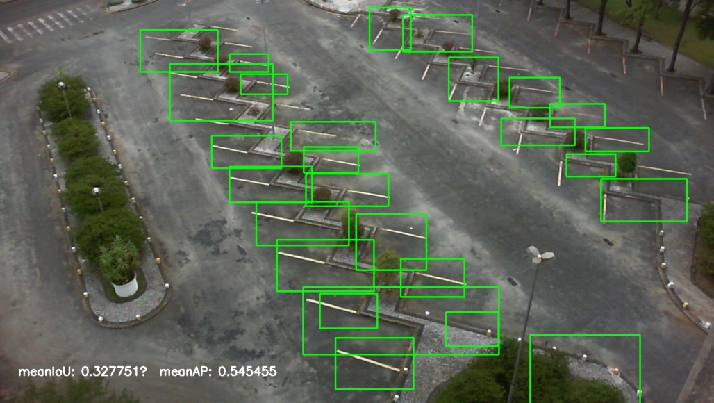

Figure : 2013-02-24_10_05_04.jpg

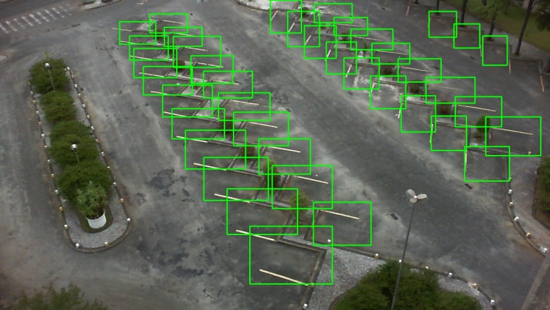

Figure : 2013-02-24_10_35_04.jpg (ground truth)

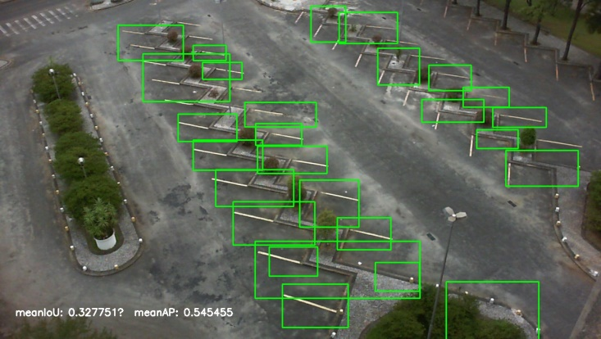

Figure : 2013-02-24_10_35_04.jpg

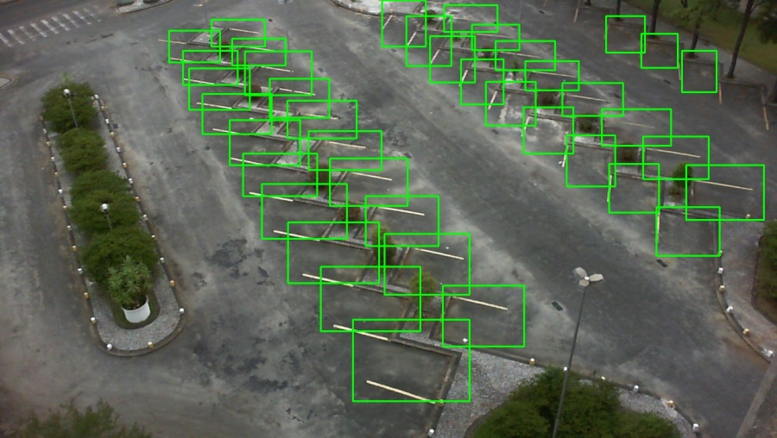

Figure : 2013-02-24_10_35_04.jpg (ground truth)

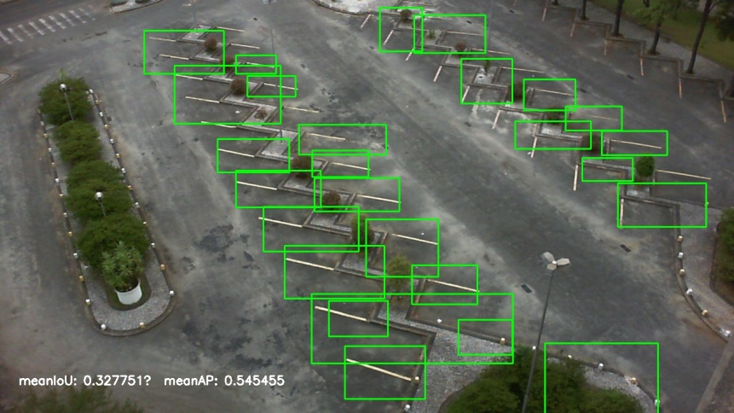

Figure : 2013-02-24_11_30_05.jpg

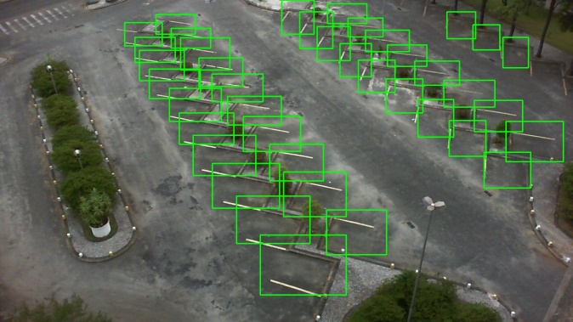

Figure : 2013-02-24_11_30_05.jpg (ground truth)

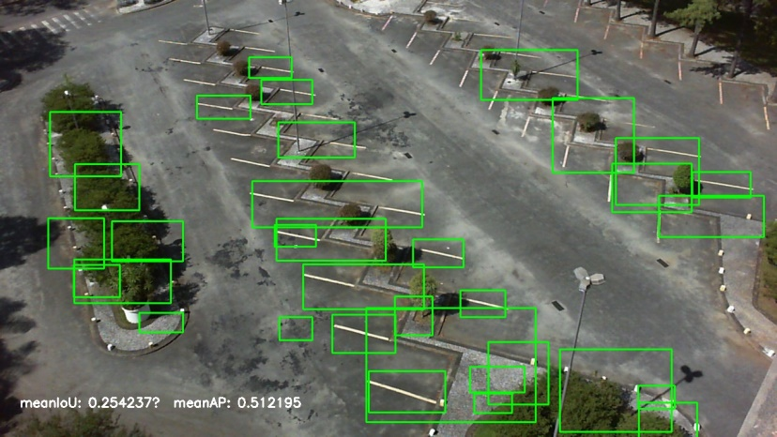

Figure : 2013-02-24_15_10_09.jpg

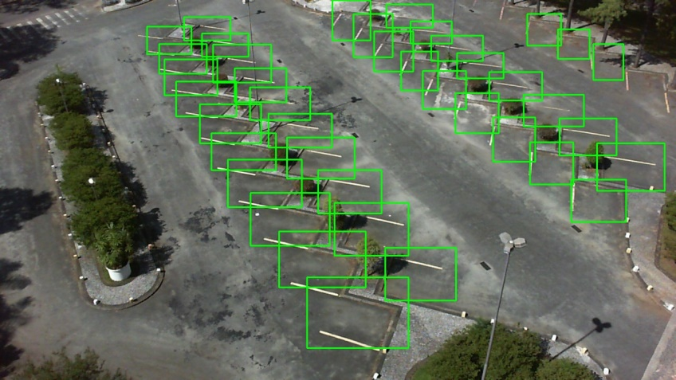

Figure : 2013-02-24_15_10_09.jpg (ground truth)

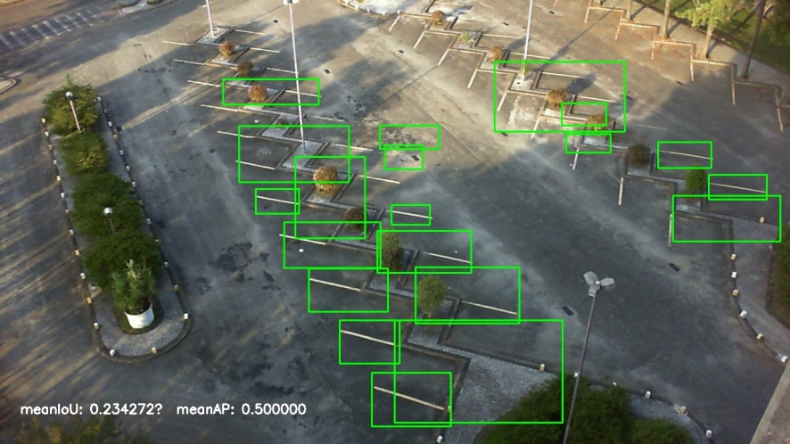

Figure : 2013-02-24_17_55_12.jpg

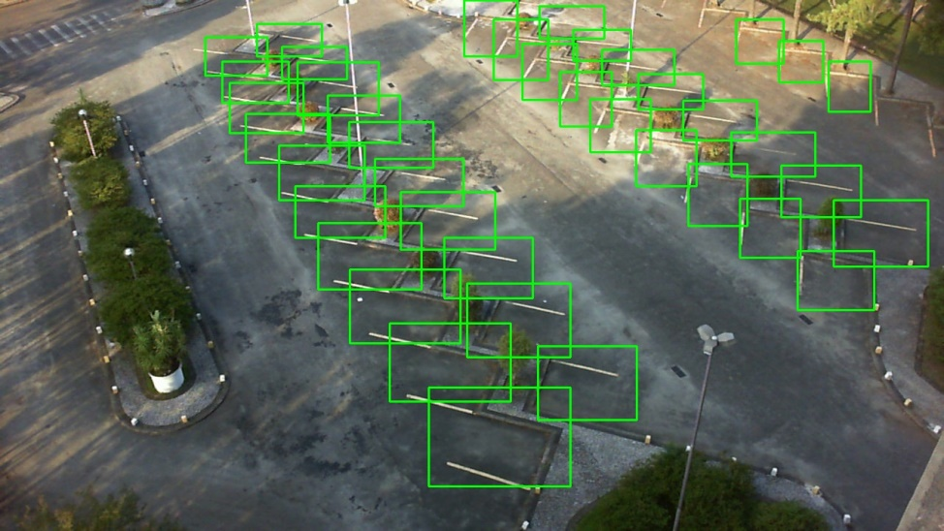

Figure : 2013-02-24_17_55_12.jpg (ground truth)

Next, we perfom car detection within the parking lot spaces and in the entire detection area. We estimate the

|  |  |  |  |
| --- | --- | --- | --- |
|  | Filename | MeanIou | meanAP |
| 1 | 2013-02-22_06_25_00.png | 0.582778 | 0.3333 |
| 1 | 2013-02-22_06_55_00.png | 0.395041 | 0.3333 |
| 1 | 2013-02-22_07_05_01.png | 0.342577 | 0.3333 |
| 1 | 2013-02-22_07_10_01.png | 0.44228 | 0.375 |
| 1 | 2013-02-22_07_15_01.png | 0.3452 | 0.3125 |
|  |  |  |  |
| 2 | 2013-03-09_07_45_02.png | 0.457317 | 0.5 |
| 2 | 2013-03-09_08_05_02.png | 0.321495 | 0.3333 |
| 2 | 2013-03-09_09_30_04.png | 0.384955 | 0.4 |
| 2 | 2013-03-09_09_45_04.png | 0.307665 | 0.5 |
| 2 | 2013-03-09_11_20_06.png | 0.377874 | 0.44444 |
|  |  |  |  |
| 3 | 2013-03-19_06_50_01.png | 0 | 0 |
| 3 | 2013-03-19_06_55_01.png | 0.304077 | 0.6 |
| 3 | 2013-03-19_07_05_01.png | 0.316563 | 0.3 |
| 3 | 2013-03-19_07_10_01.png | 0.38921 | 0.230769 |
| 3 | 2013-03-19_07_25_01.png | 0.375743 | 0.142857 |
|  |  |  |  |
| 4 | 2013-04-15_07_05_01.png | 0.382767 | 0.25 |
| 4 | 2013-04-15_07_10_01.png | 0.453265 | 0.1875 |
| 4 | 2013-04-15_07_15_01.png | 0.323933 | 0.25 |
| 4 | 2013-04-15_07_25_01.png | 0.367206 | 0.18571 |
| 4 | 2013-04-15_07_35_01.png | 0.345482 | 0.103448 |
|  |  |  |  |
| 5 | 2013-04-12_14_20_09.png | 0.356919 | 0.351351 |
| 5 | 2013-04-12_14_45_09.png | 0.450177 | 0.408163 |
| 5 | 2013-04-12_14_50_09.png | 0.317151 | 0.404255 |
| 5 | 2013-04-12_14_55_09.png | 0.365097 | 0.3 |
| 5 | 2013-04-12_15_00_09.png | 0.305206 | 0.375 |

Sequence 1 detections

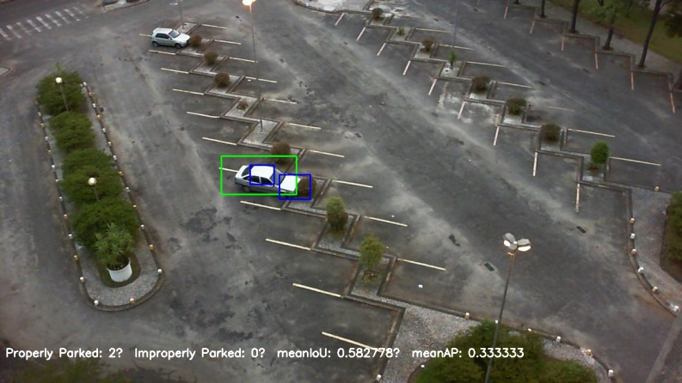

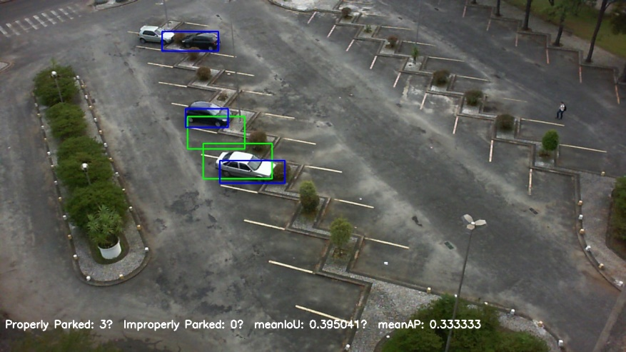

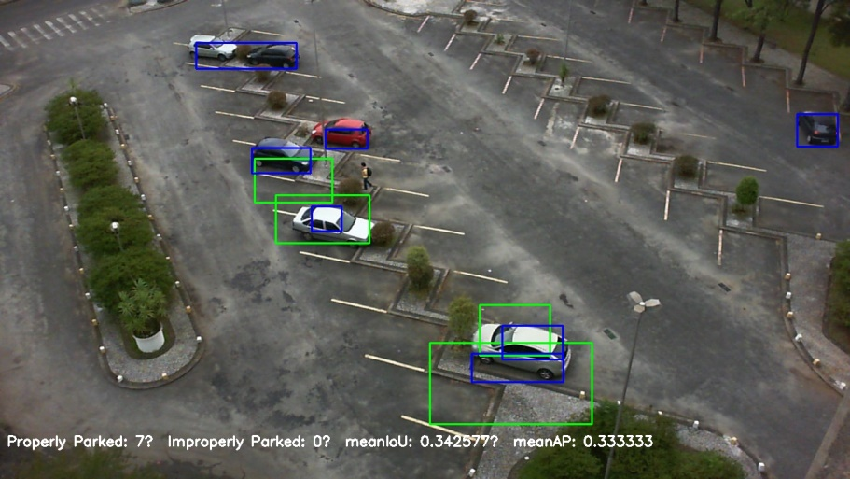

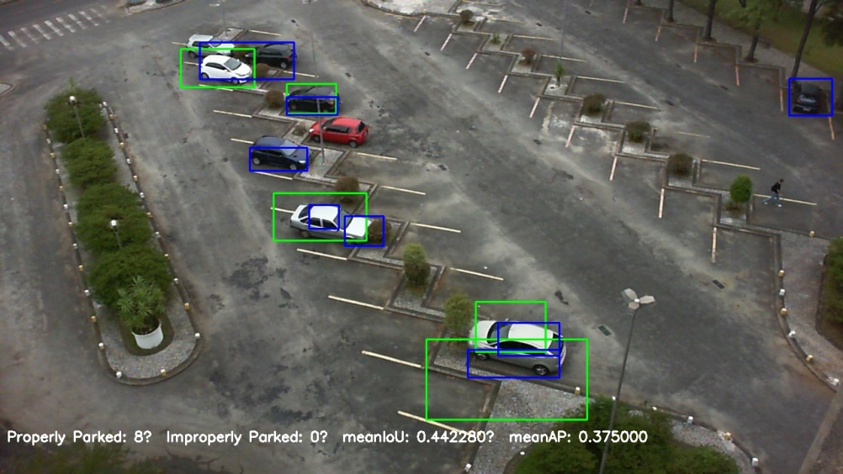

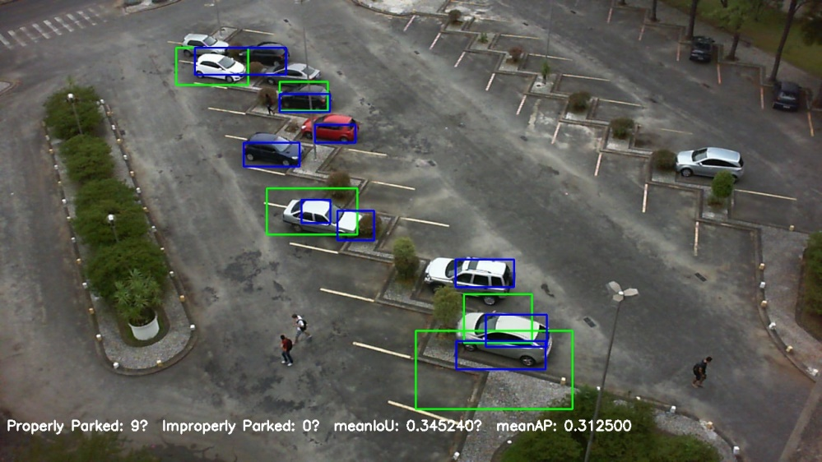

Mini maps

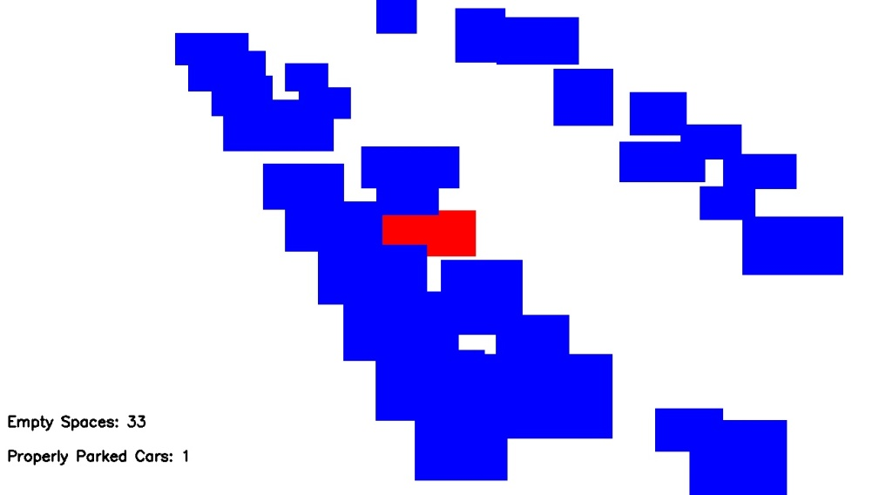

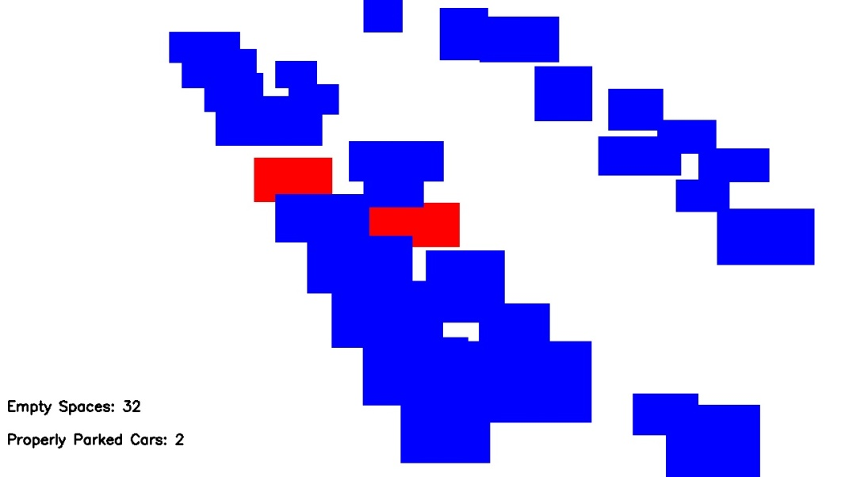

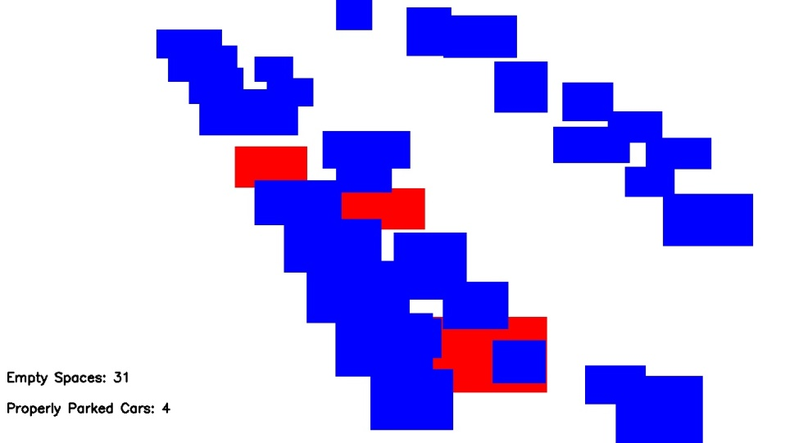

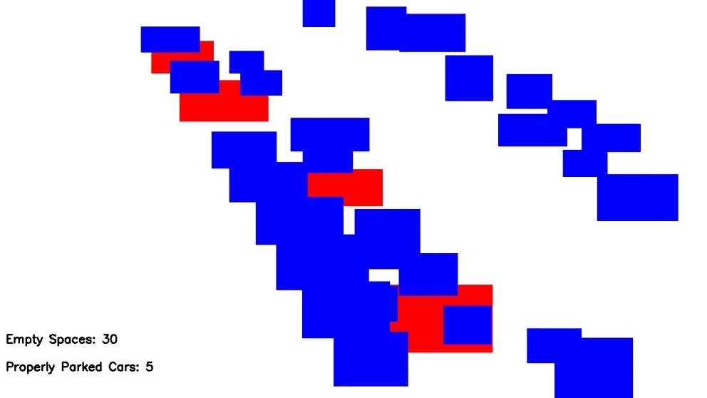

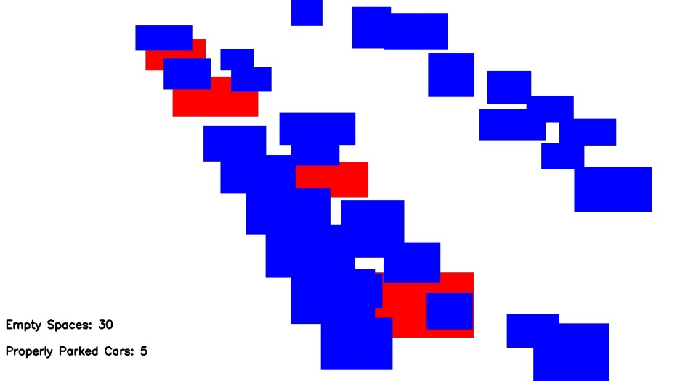

Sequence 1 ground truth

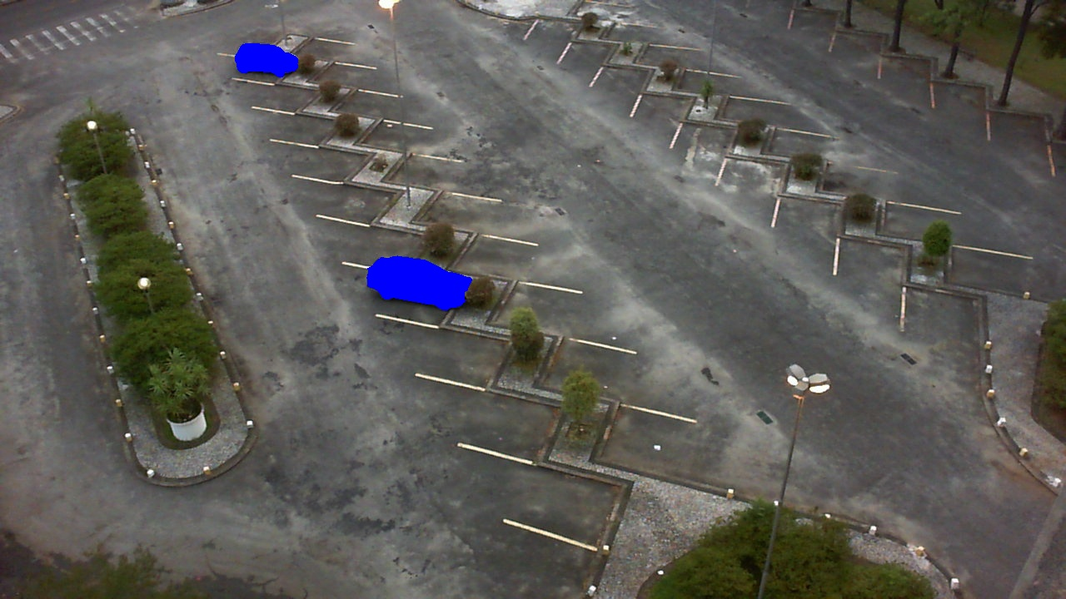

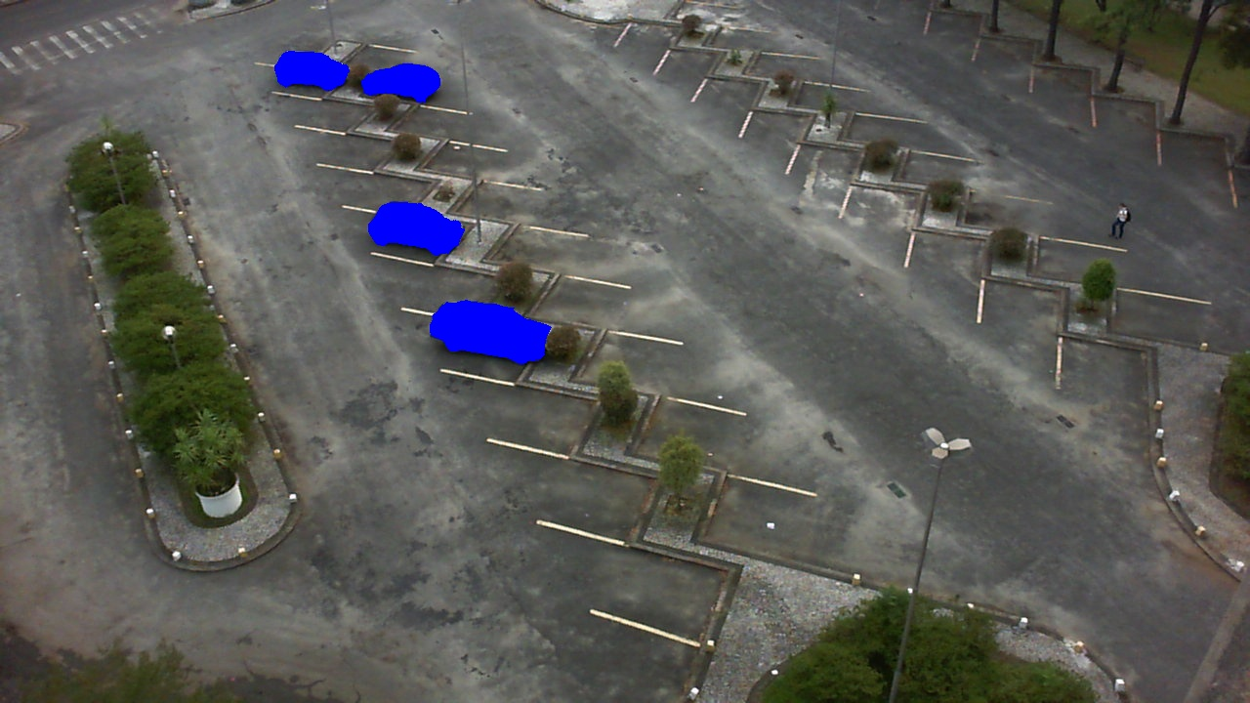

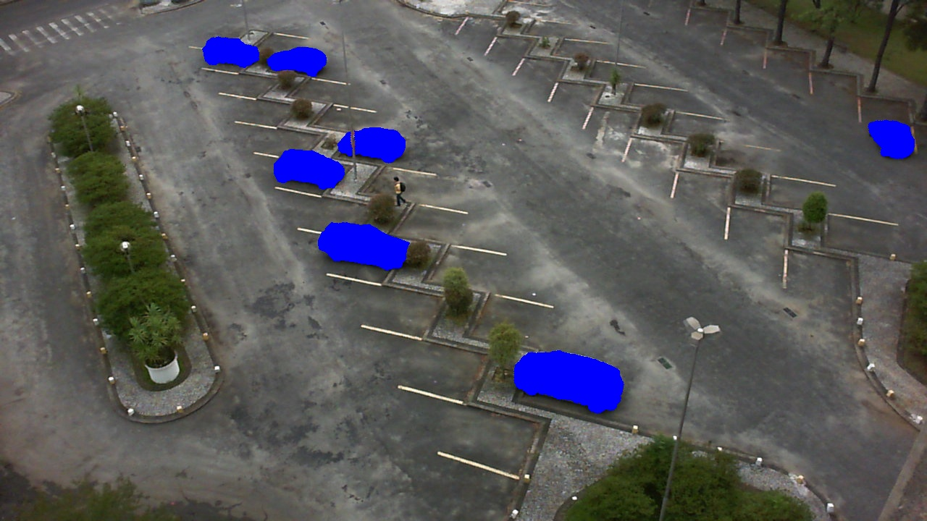

\

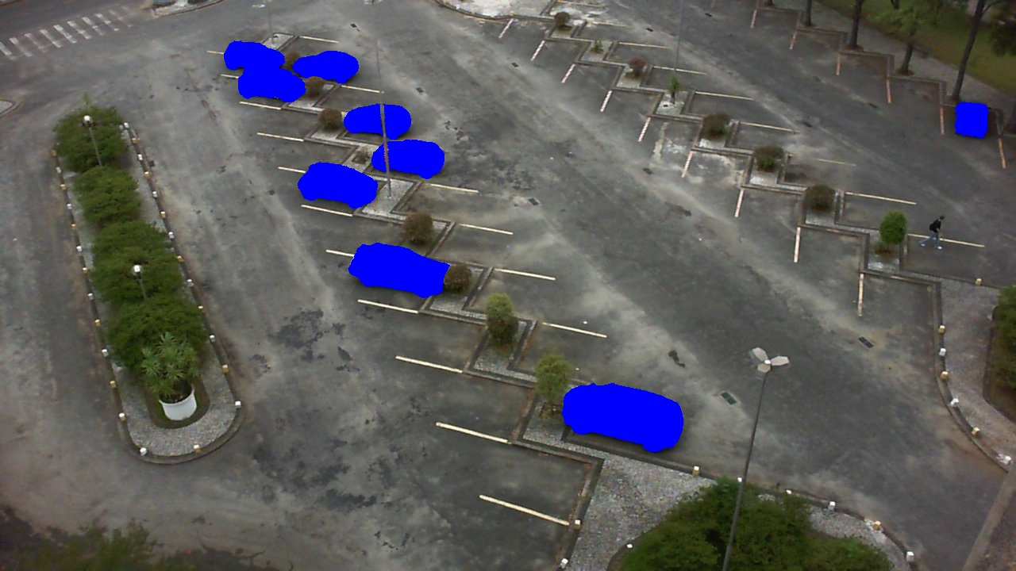

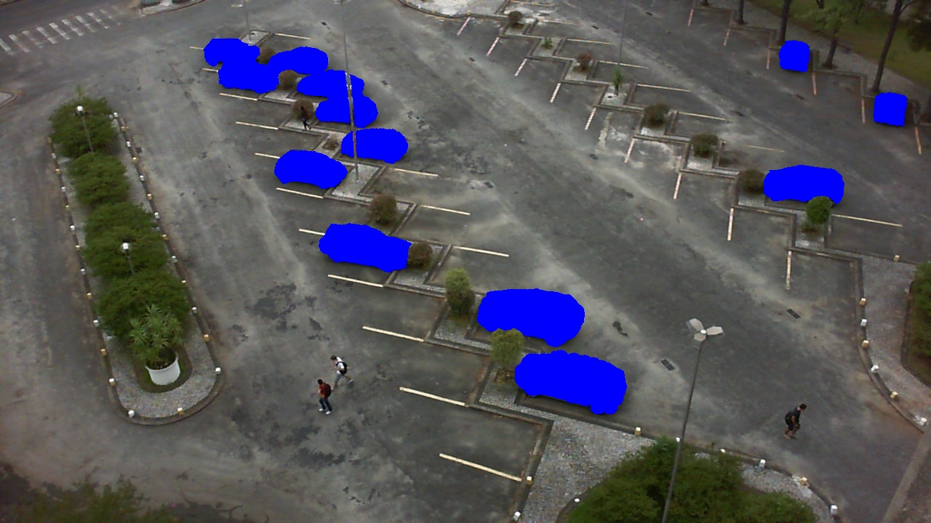

Sequence 2

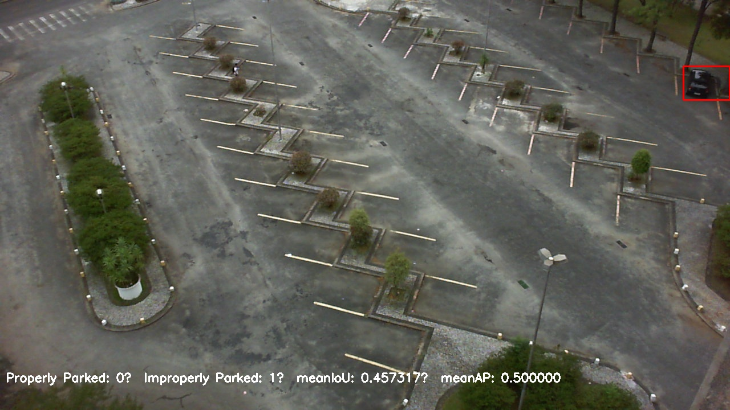

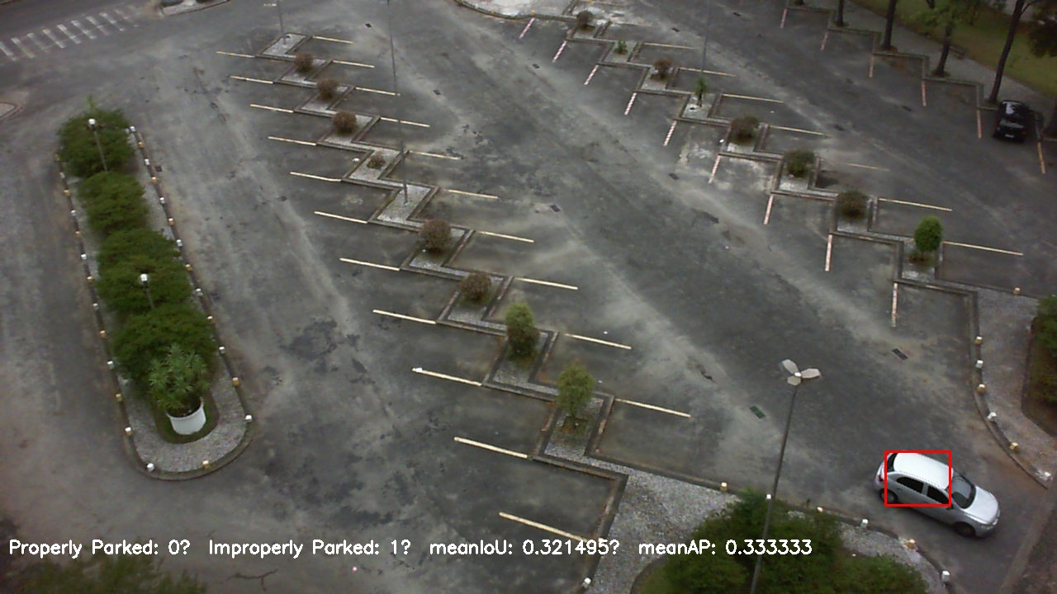

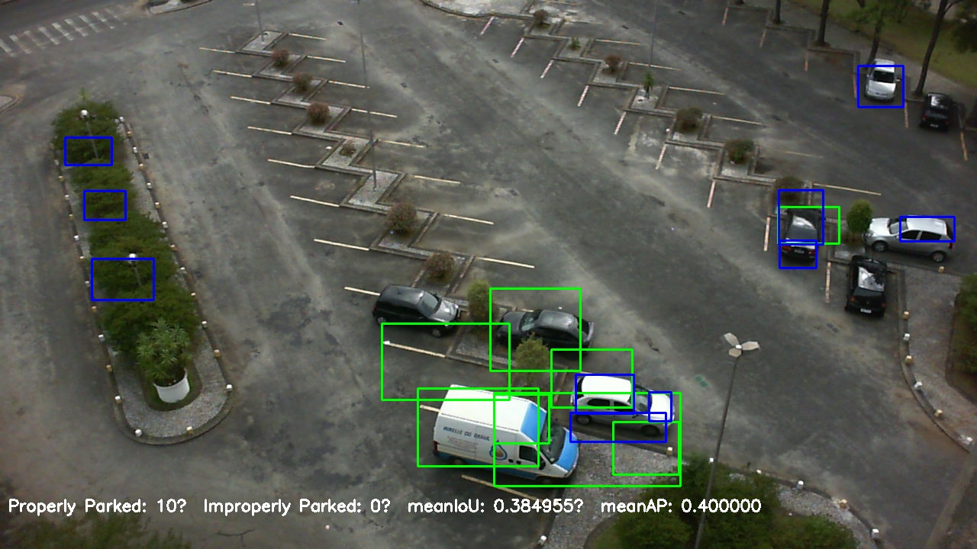

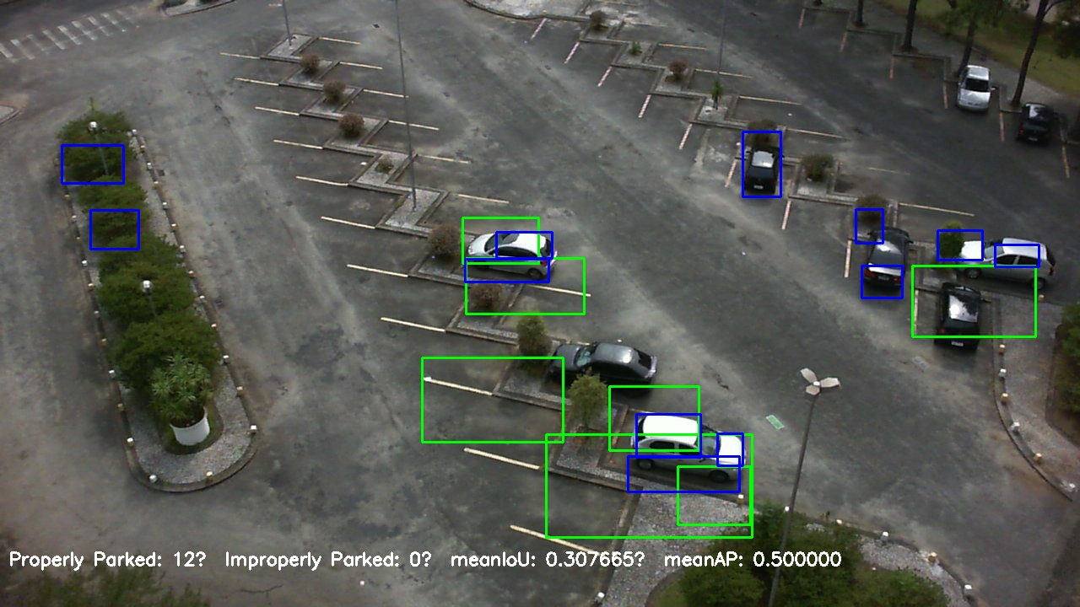

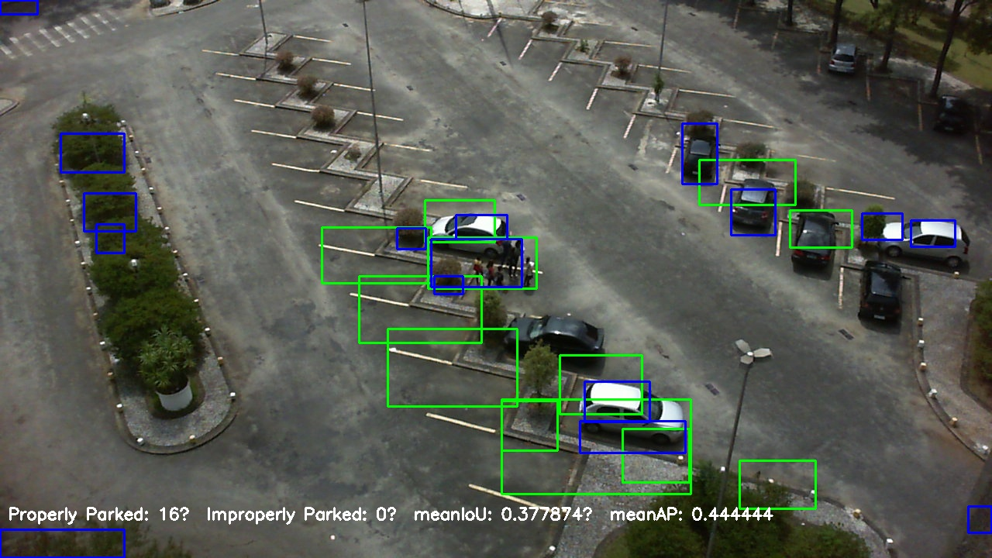

Sequence 2 minimaps

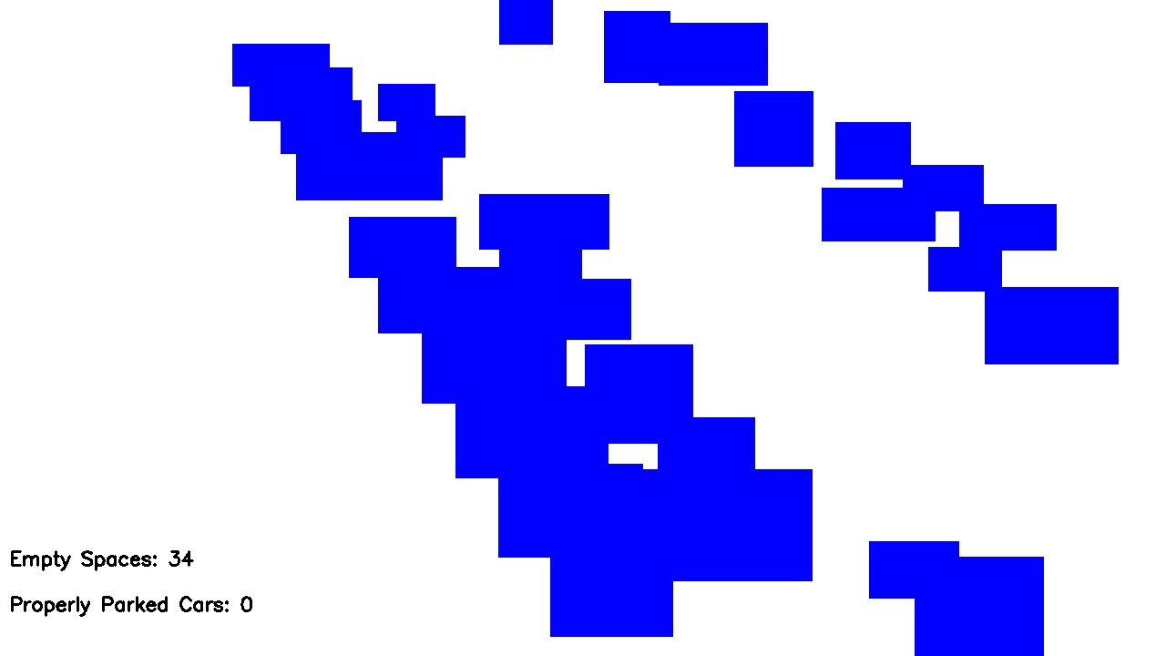



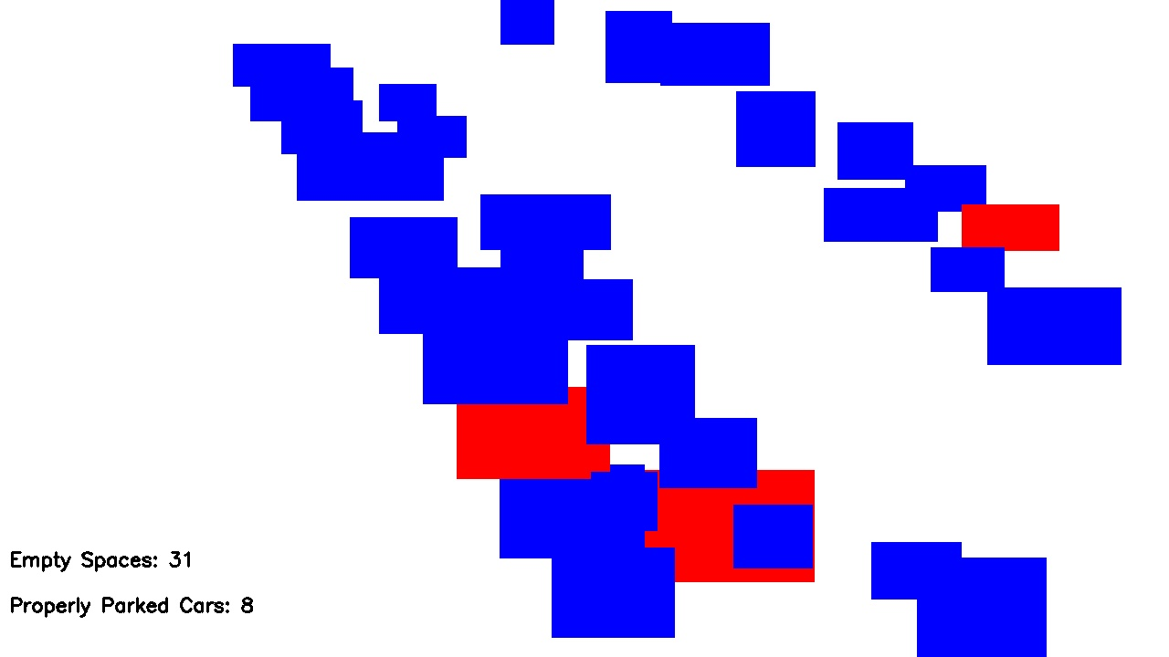

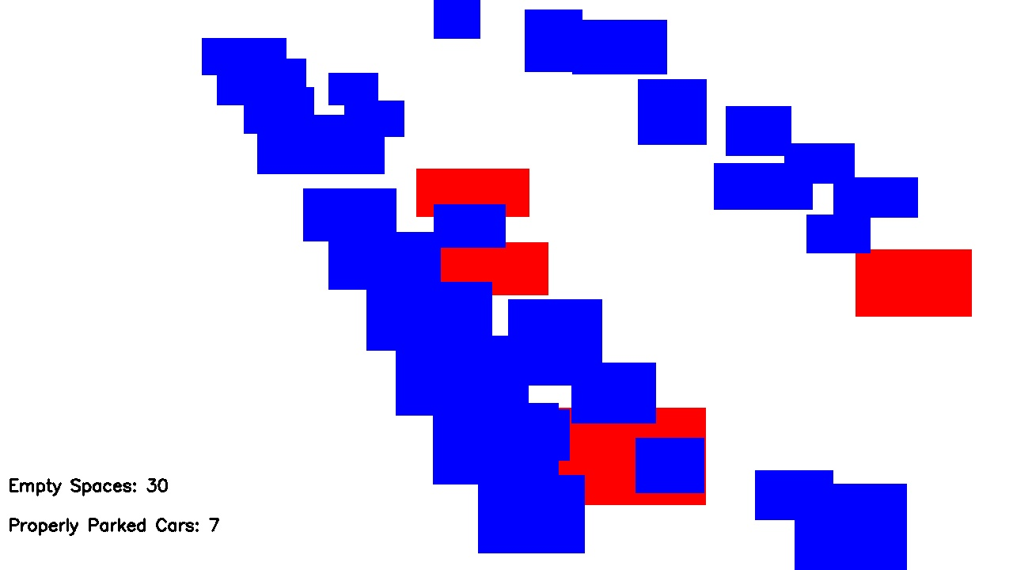

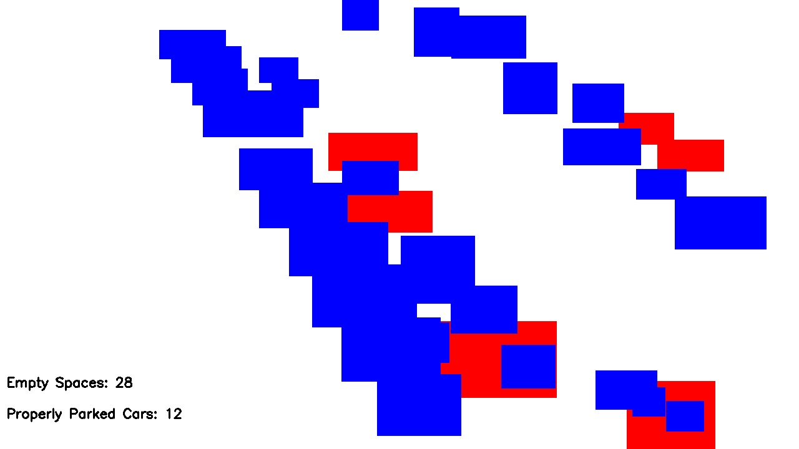

**Sequence 2 ground truth**

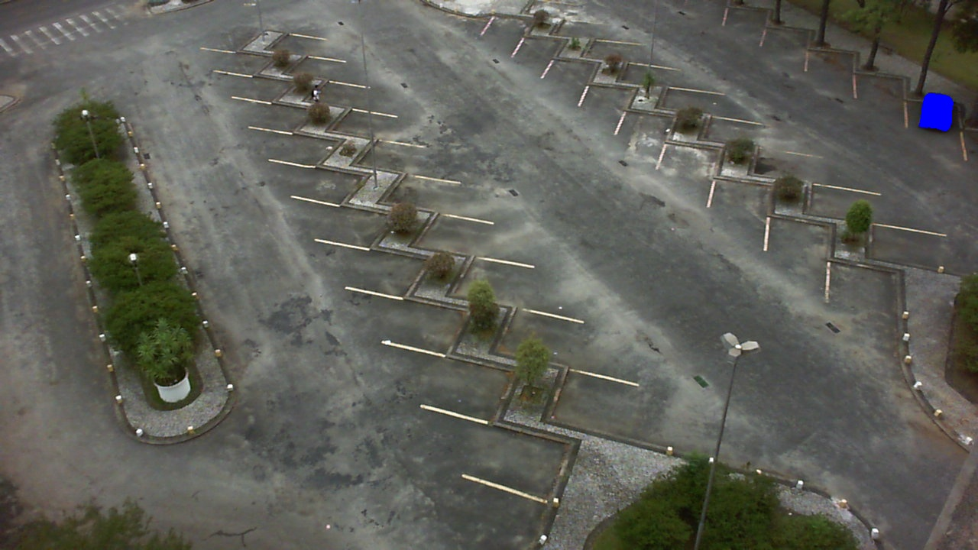

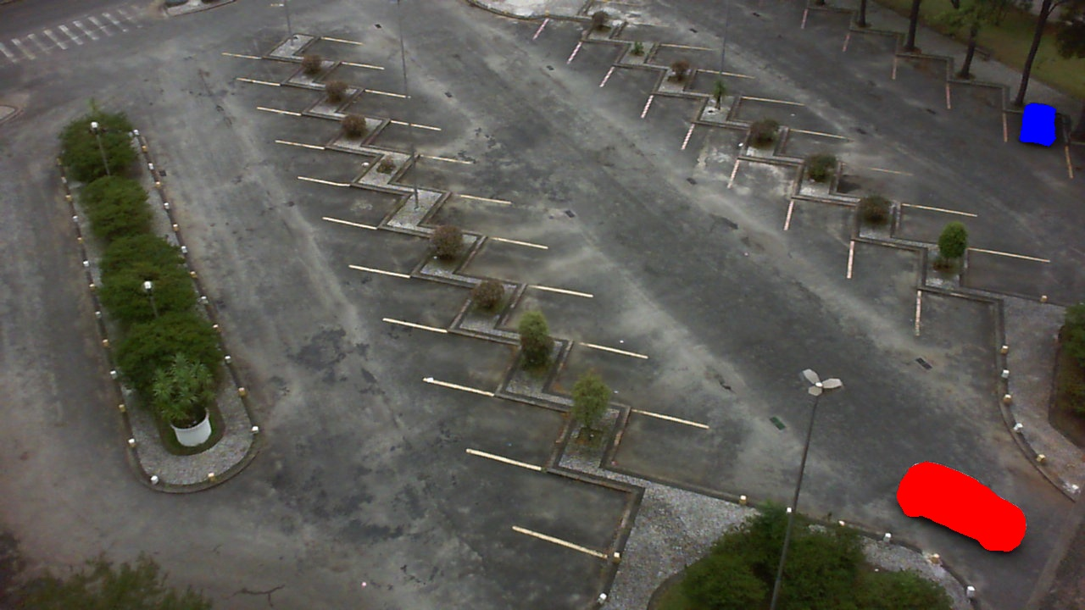

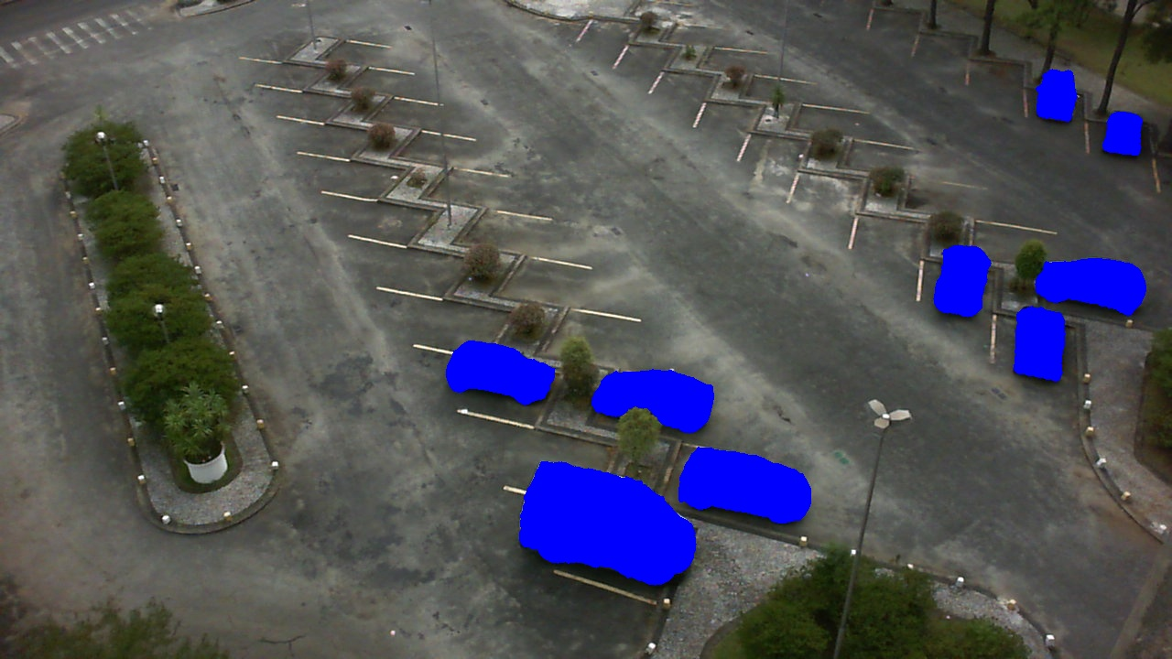

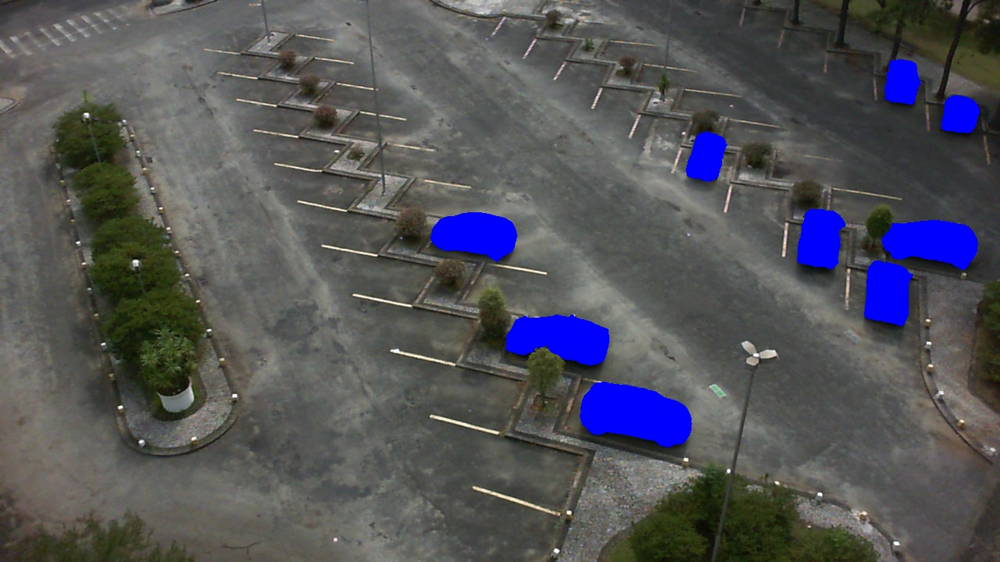

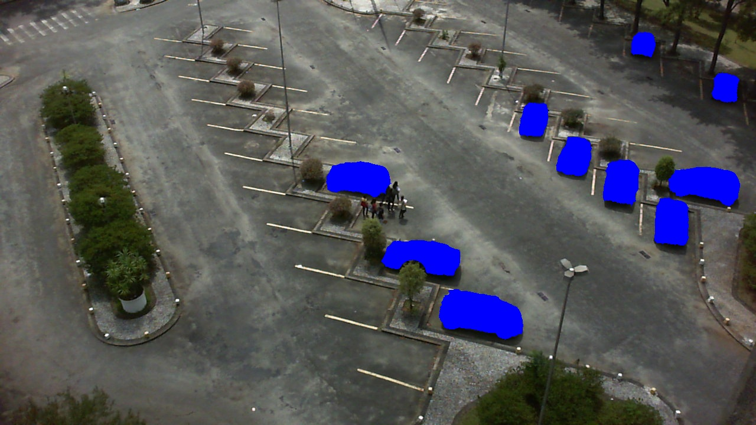

**Sequence 3**

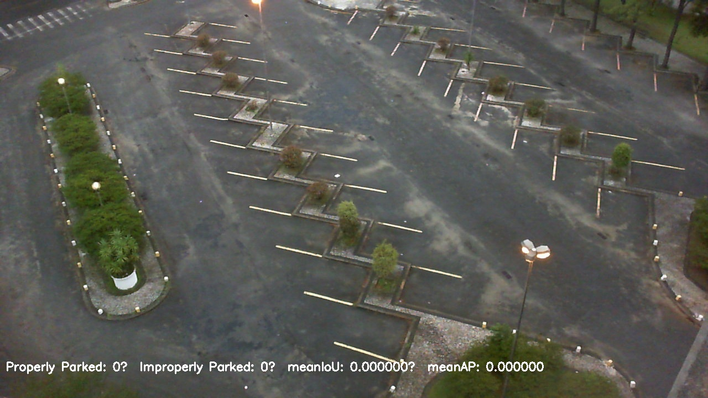

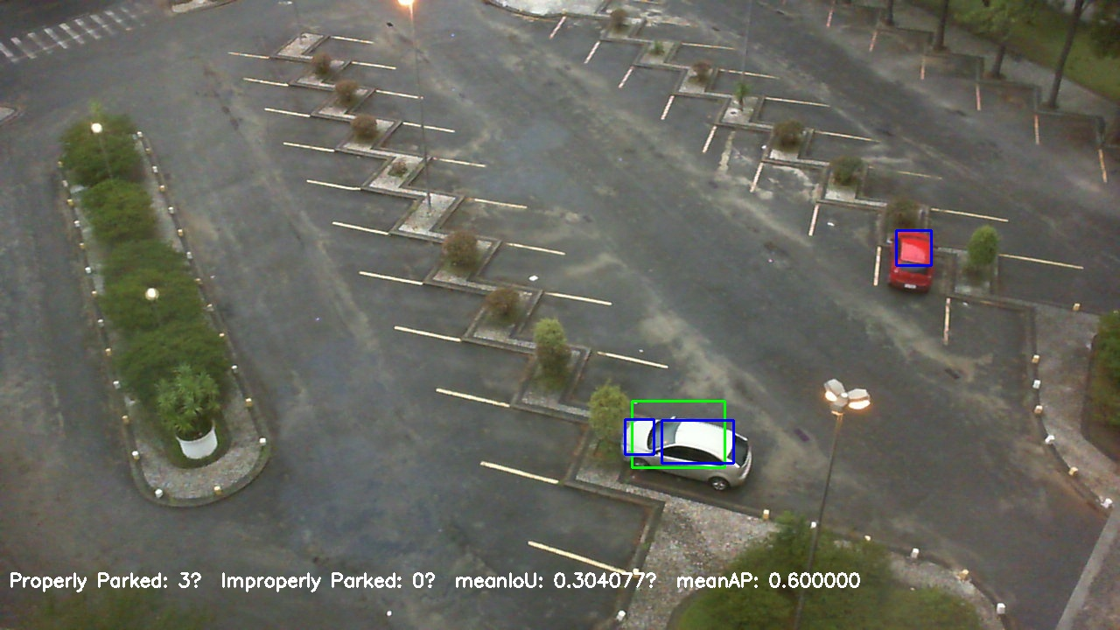

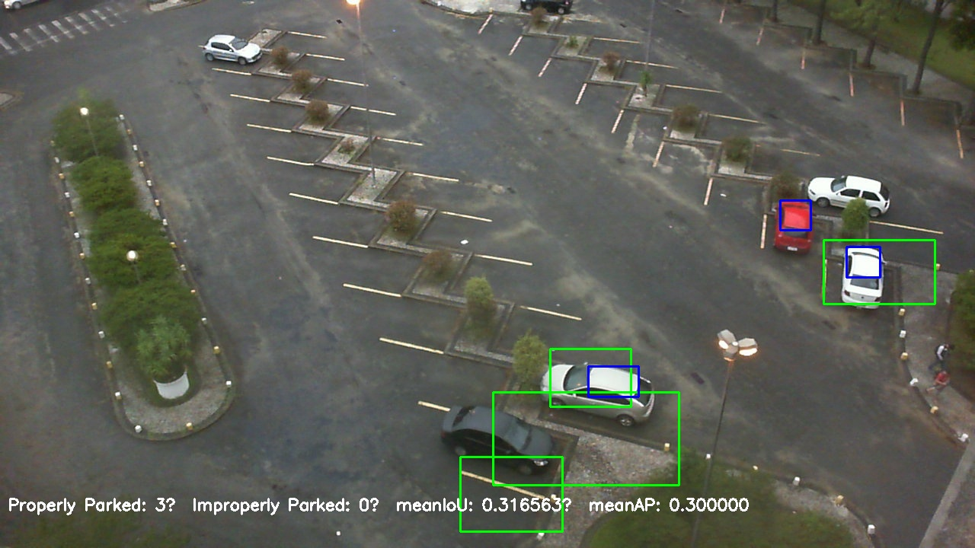

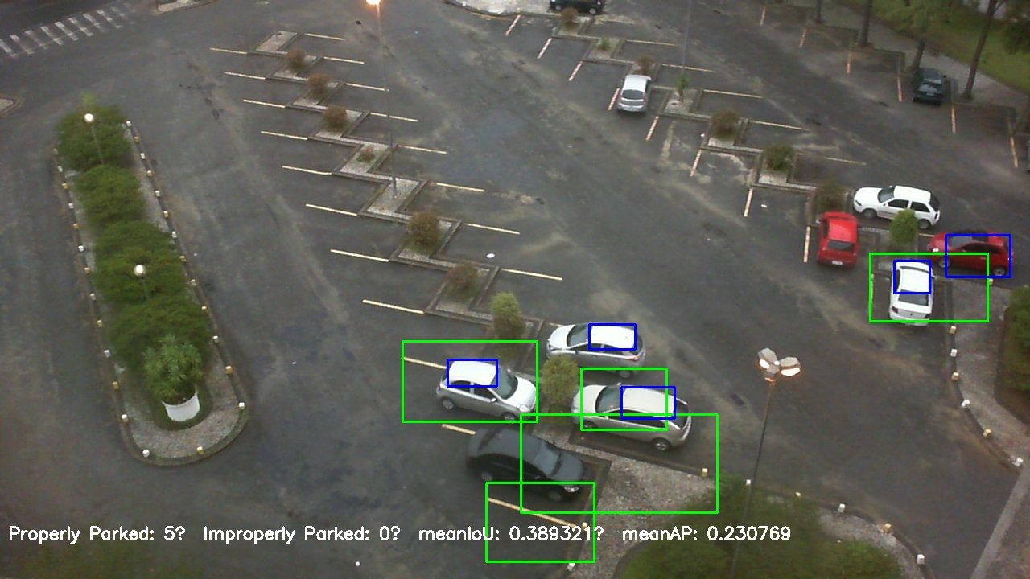

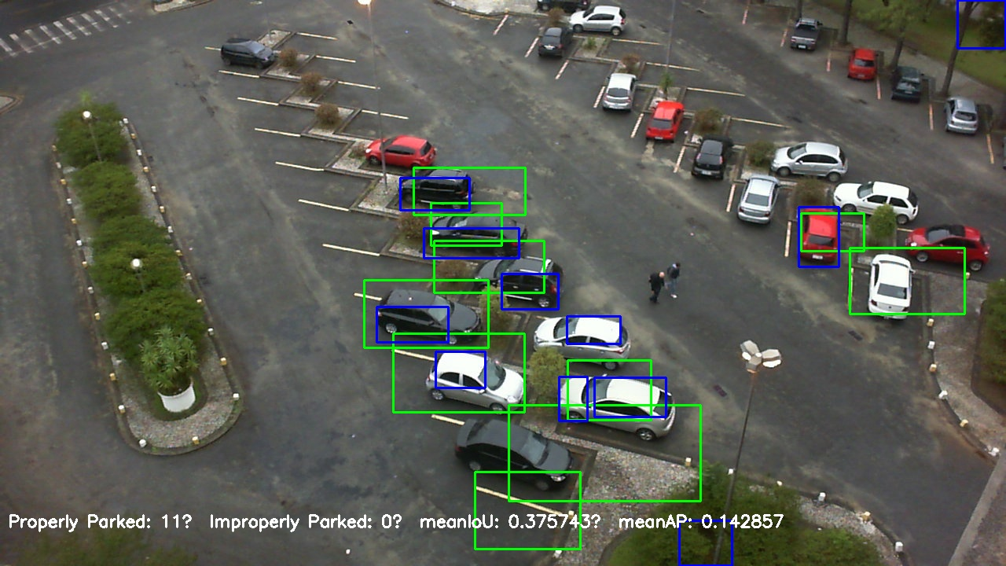

**Sequence 3 mini maps**



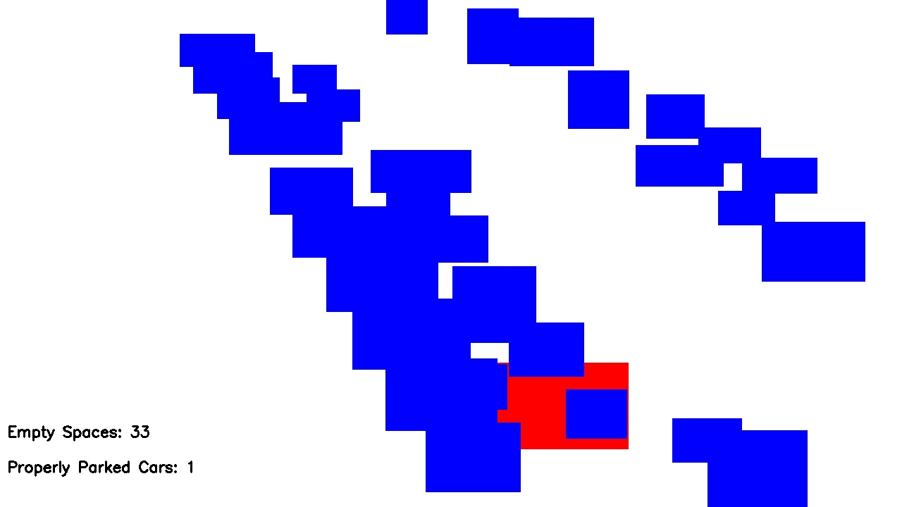

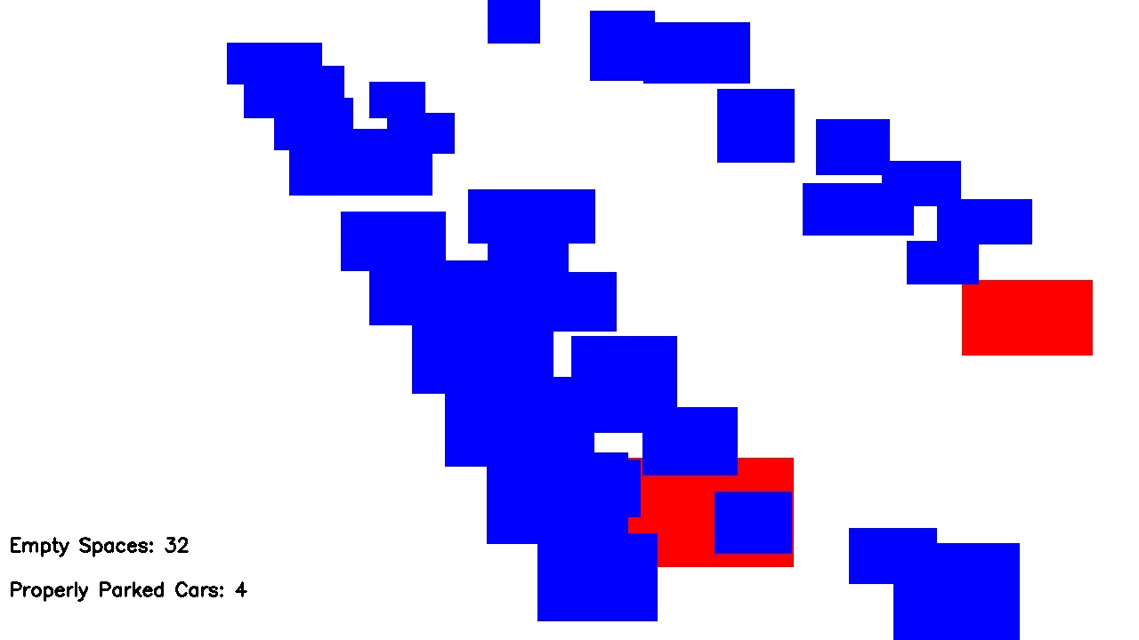

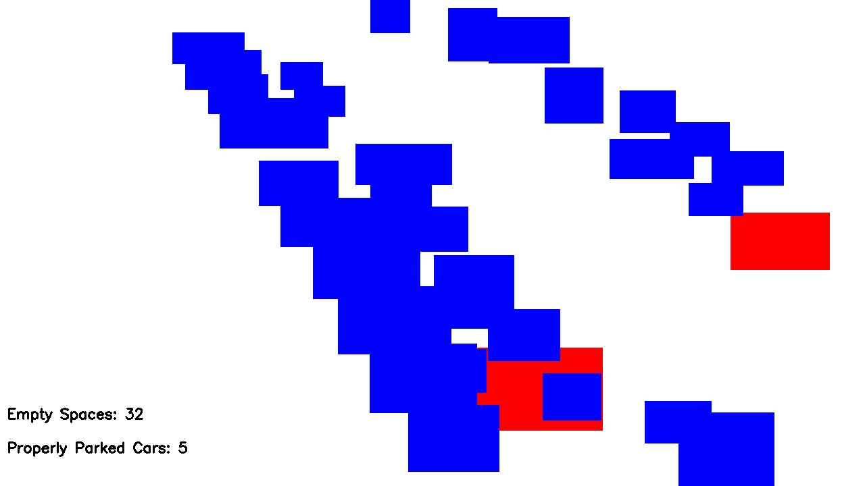

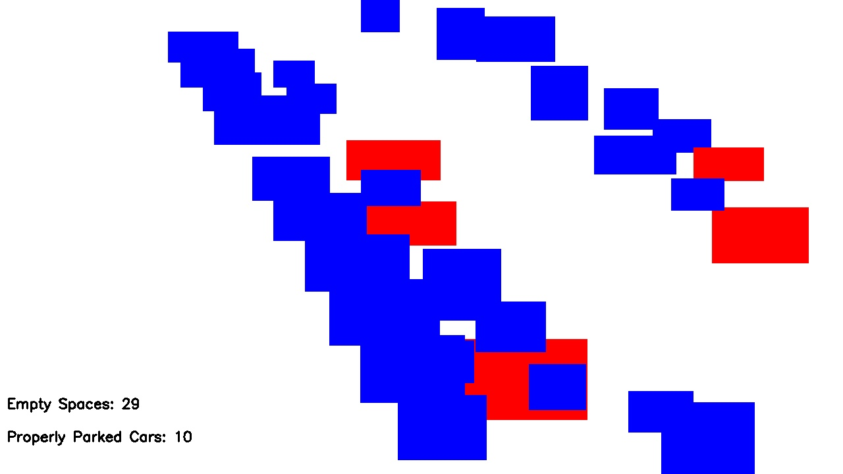

**Sequence 3 ground truth**

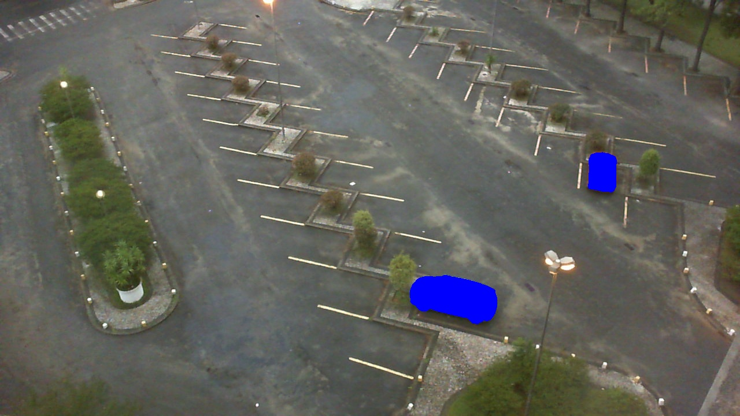

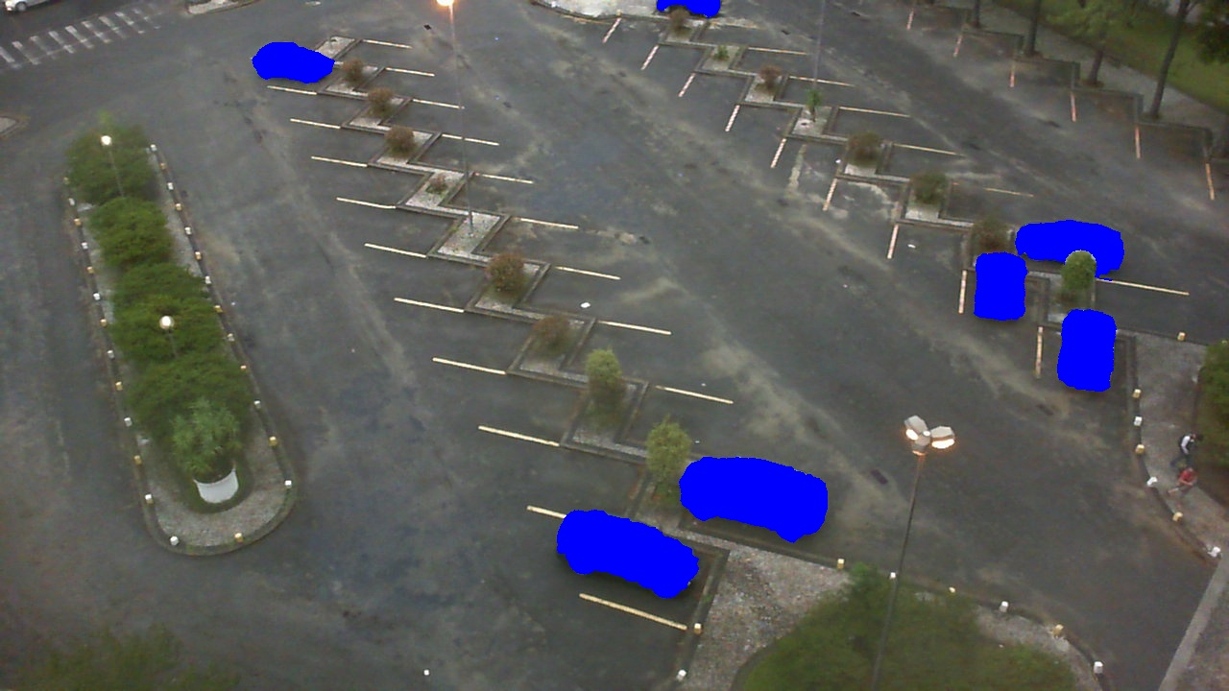

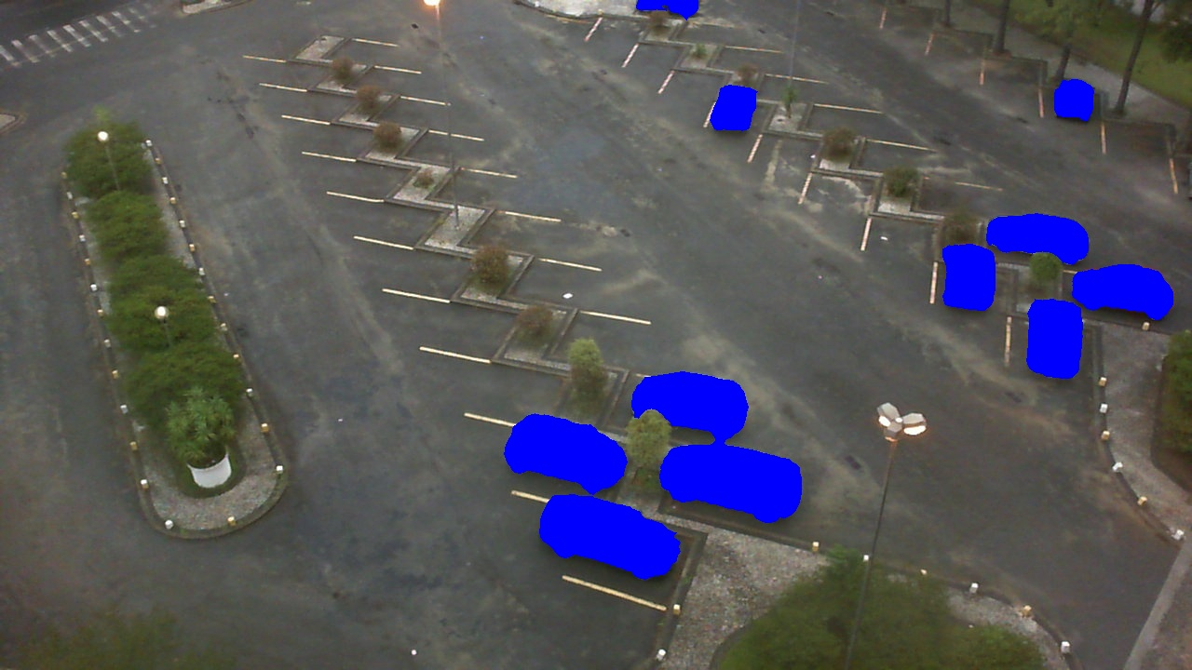

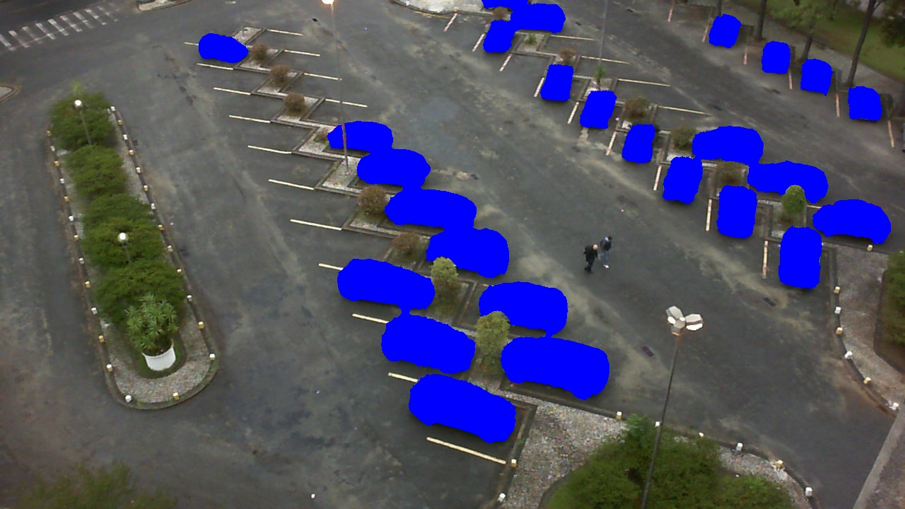

**Sequence 4**

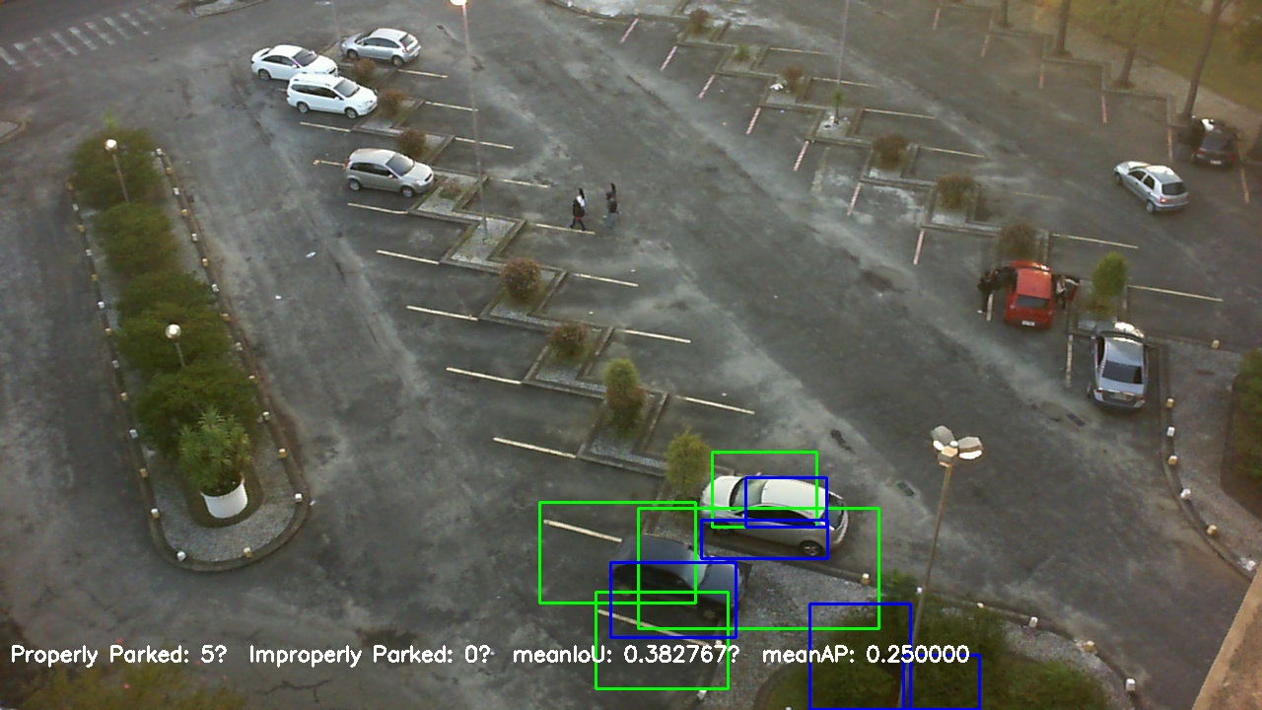

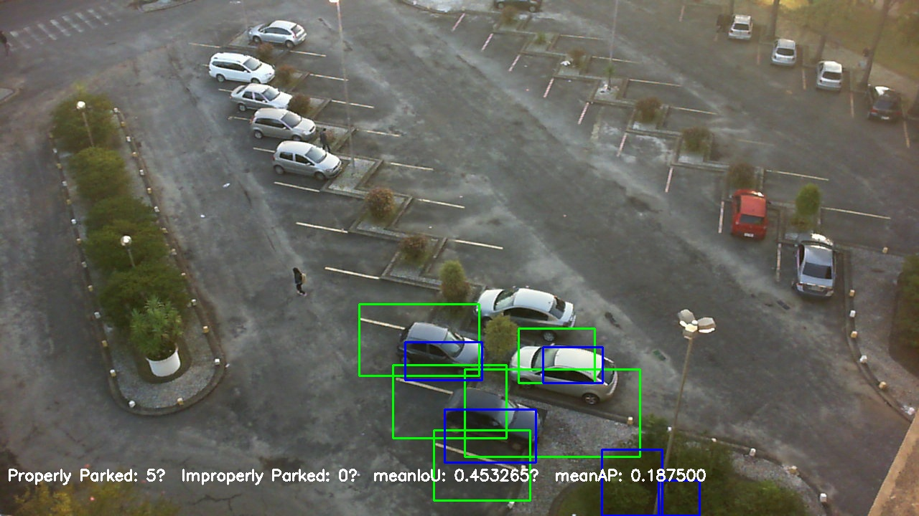

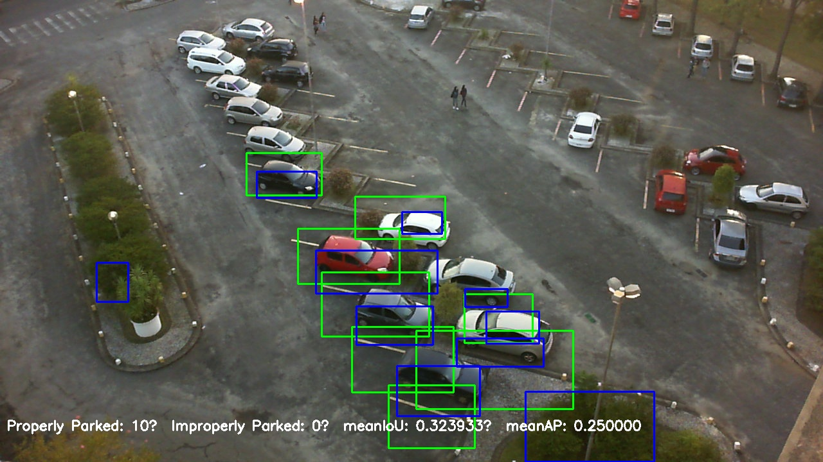

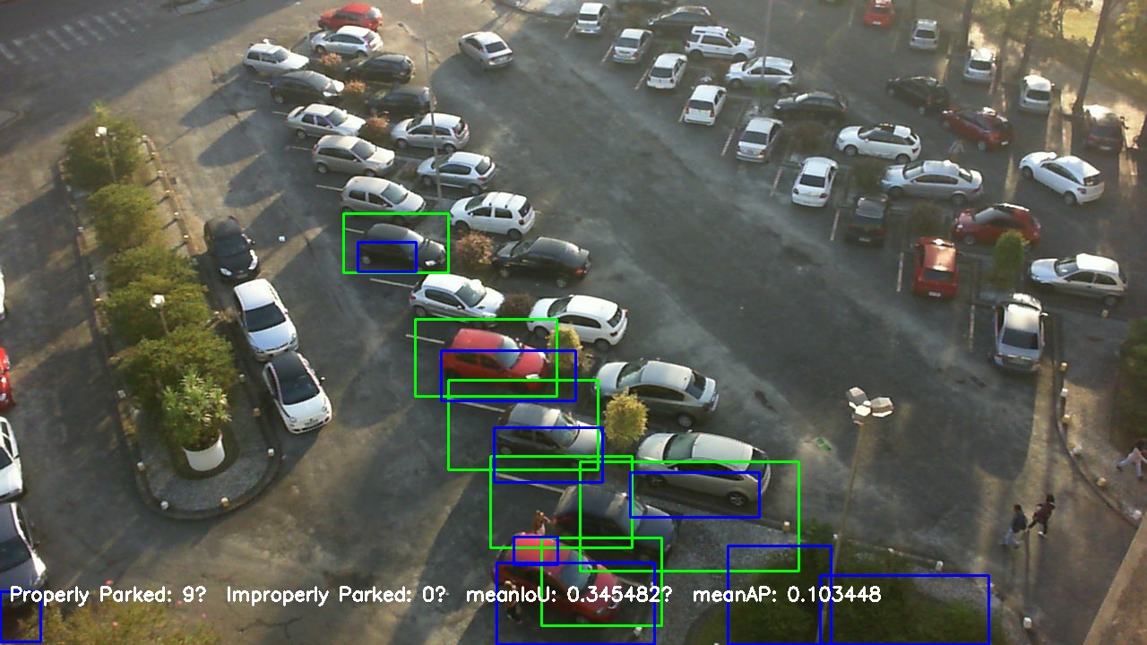

**Sequence 4 minimap**

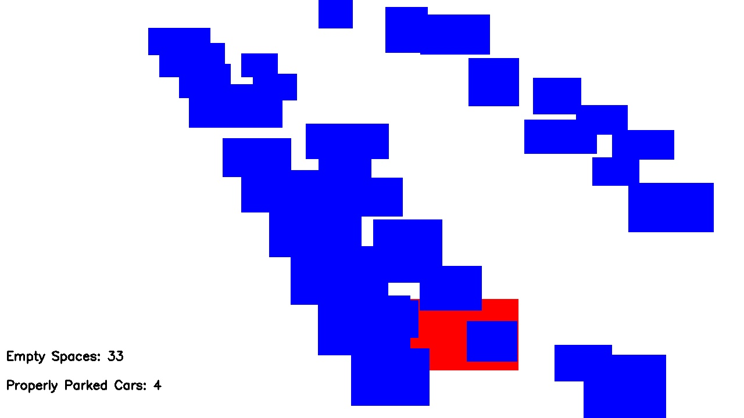

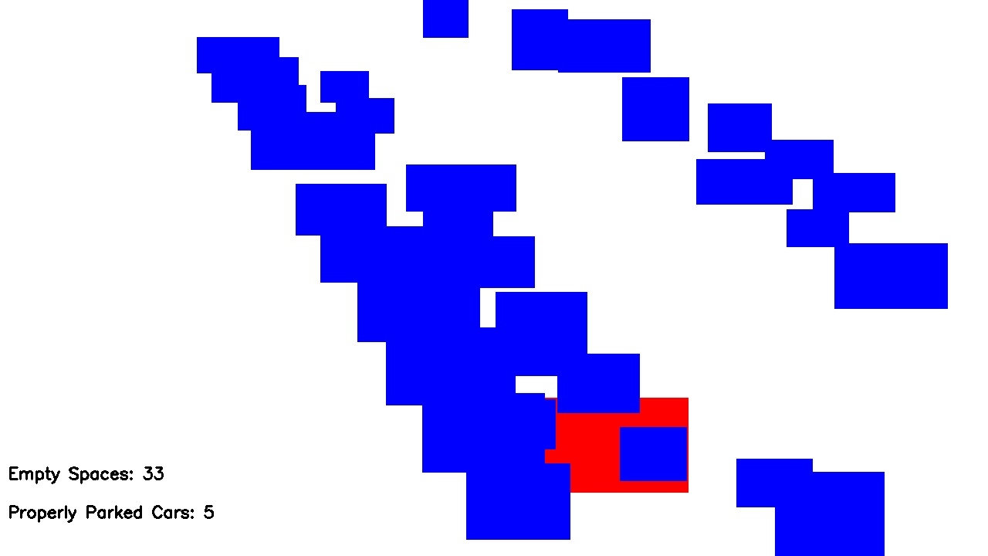

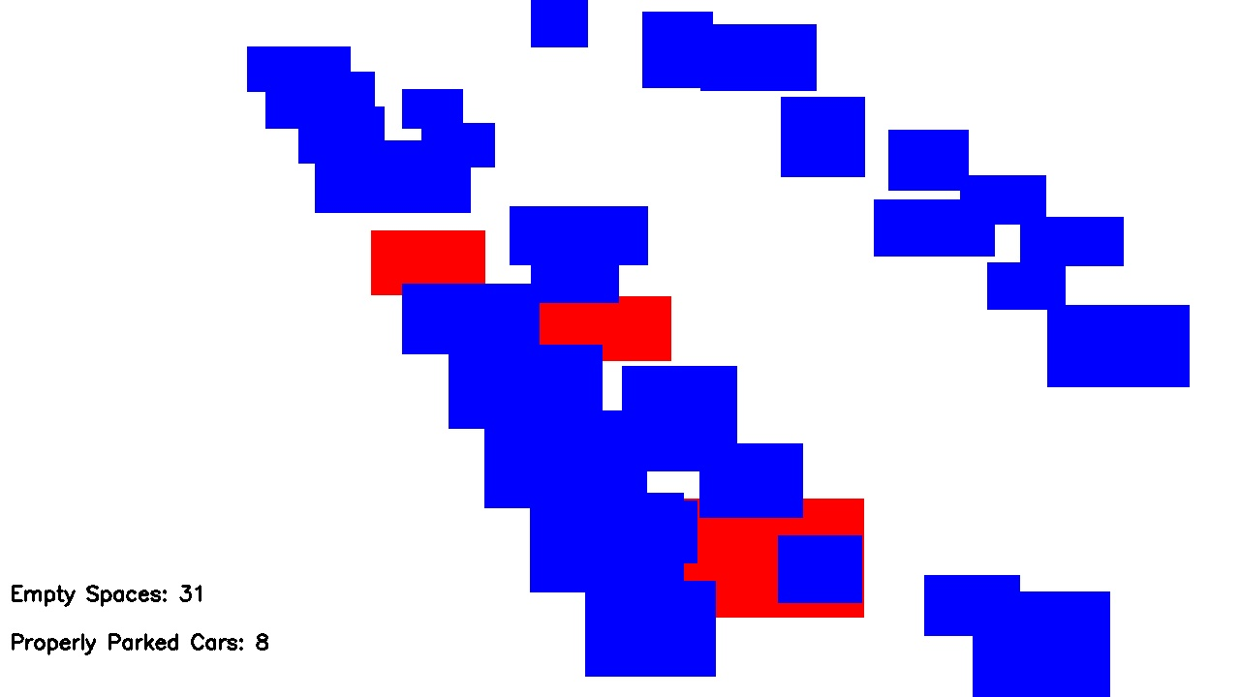

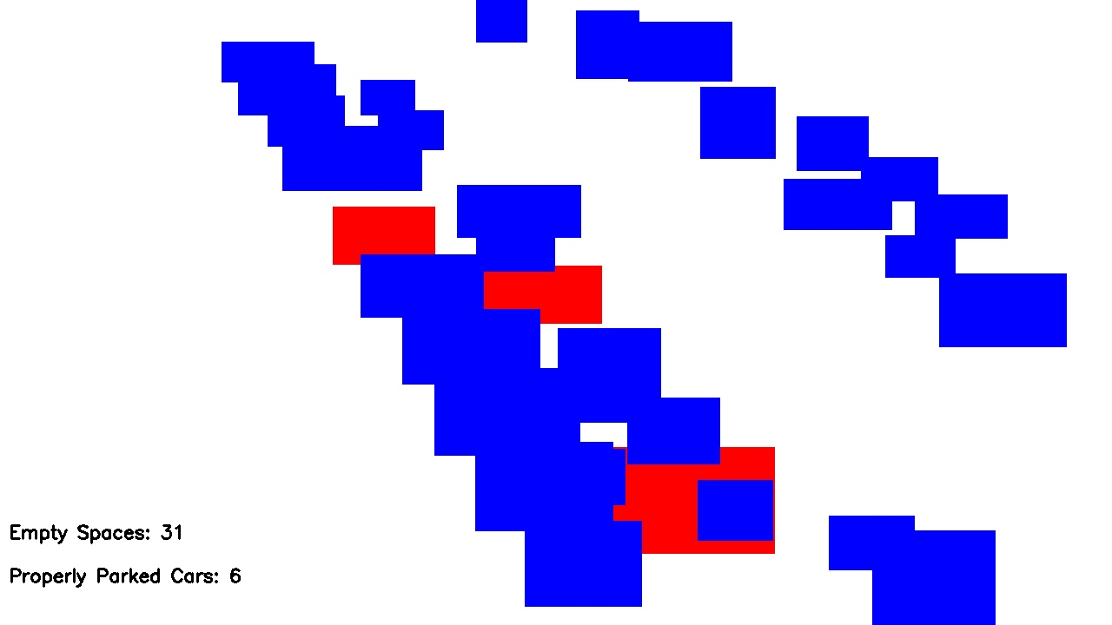

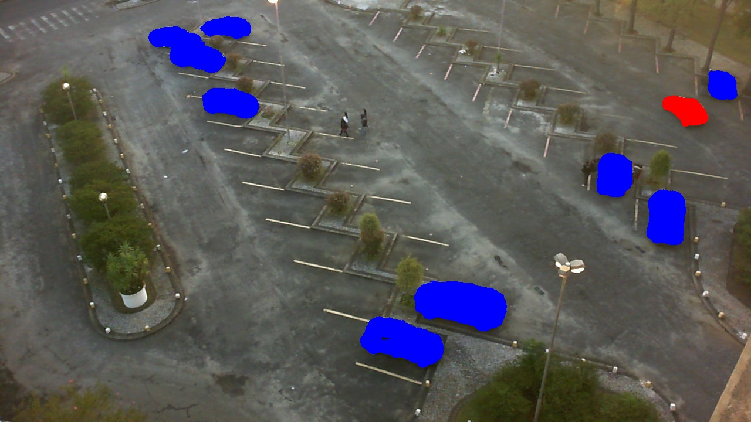

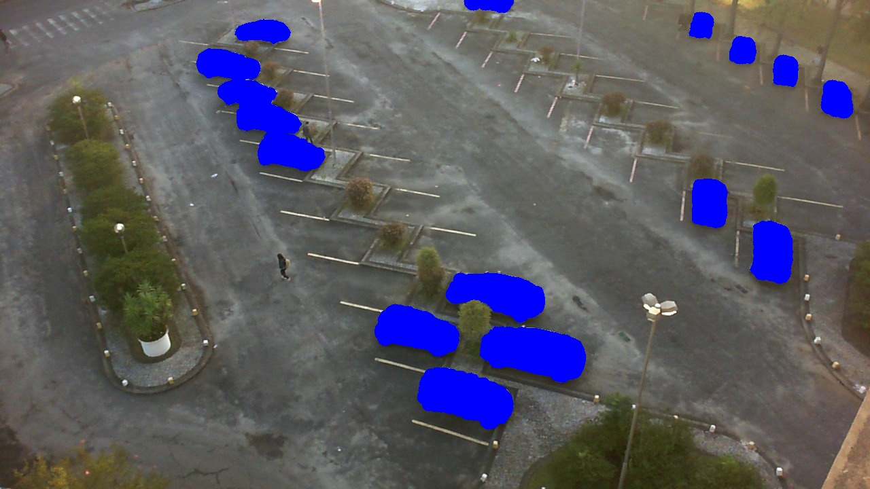

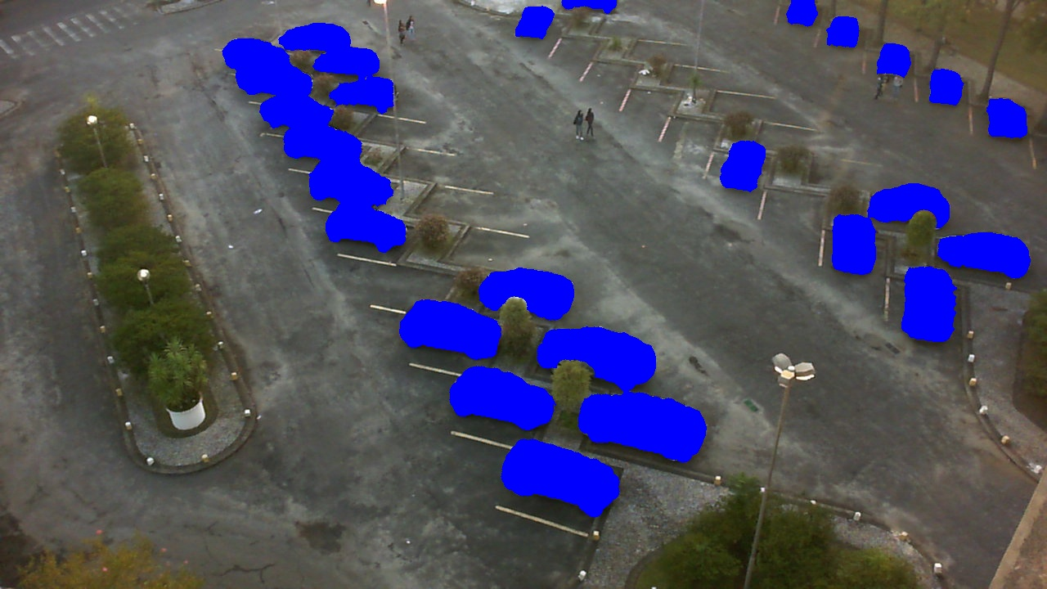

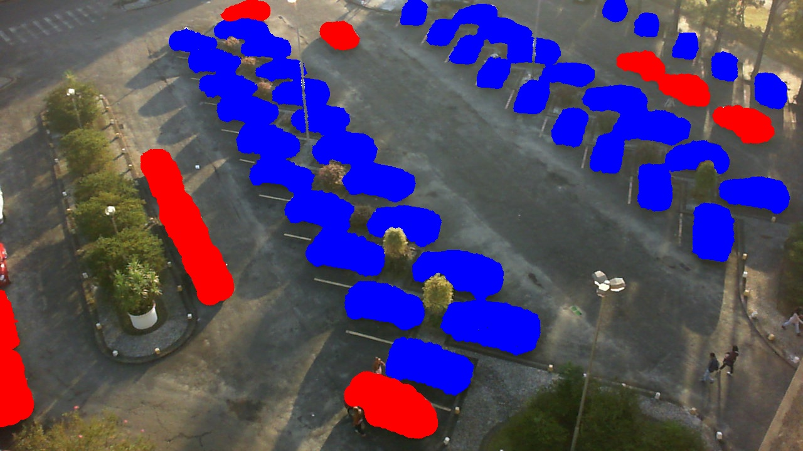

**Sequence 5**

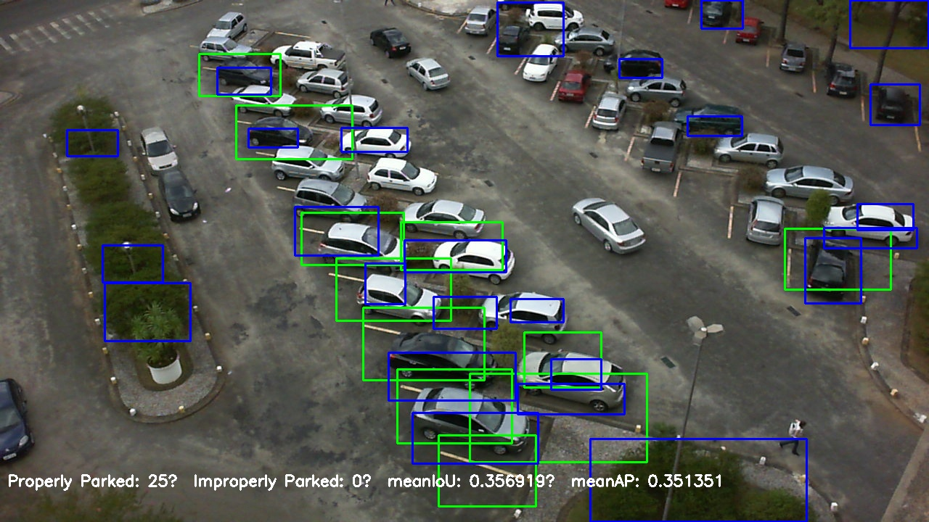

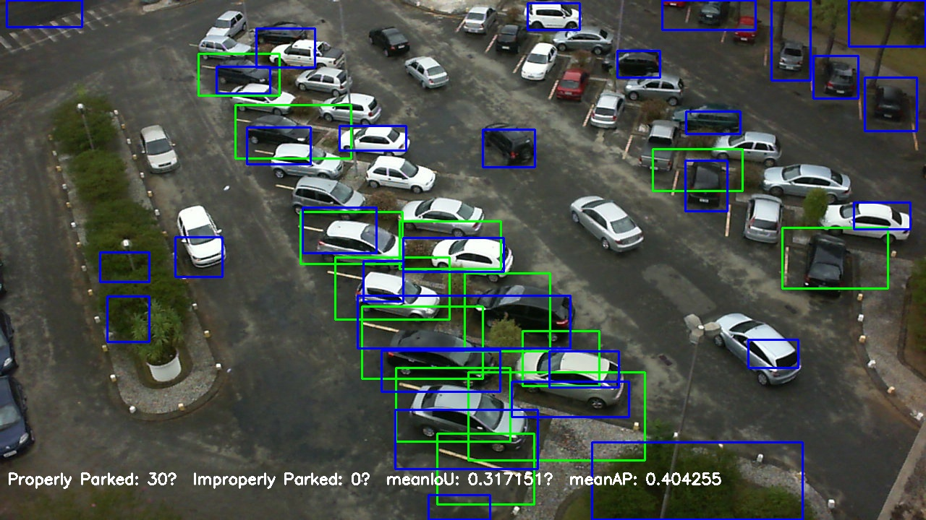

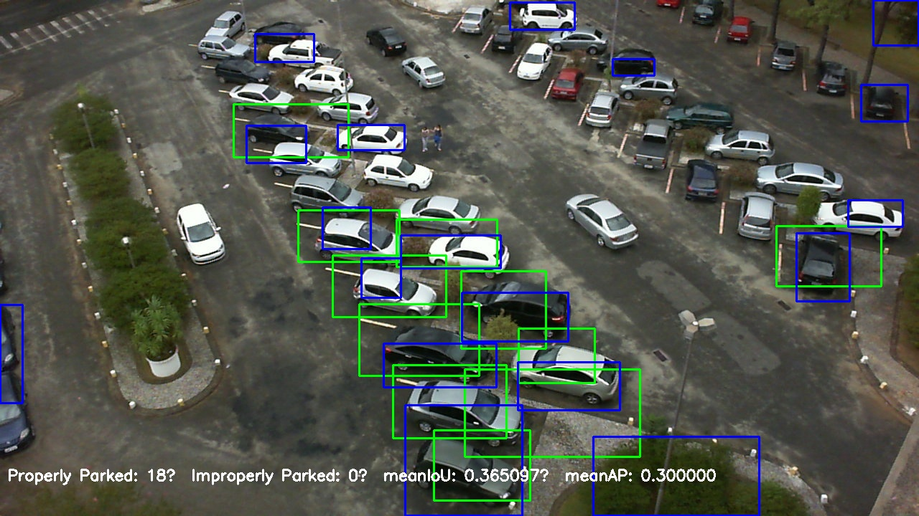

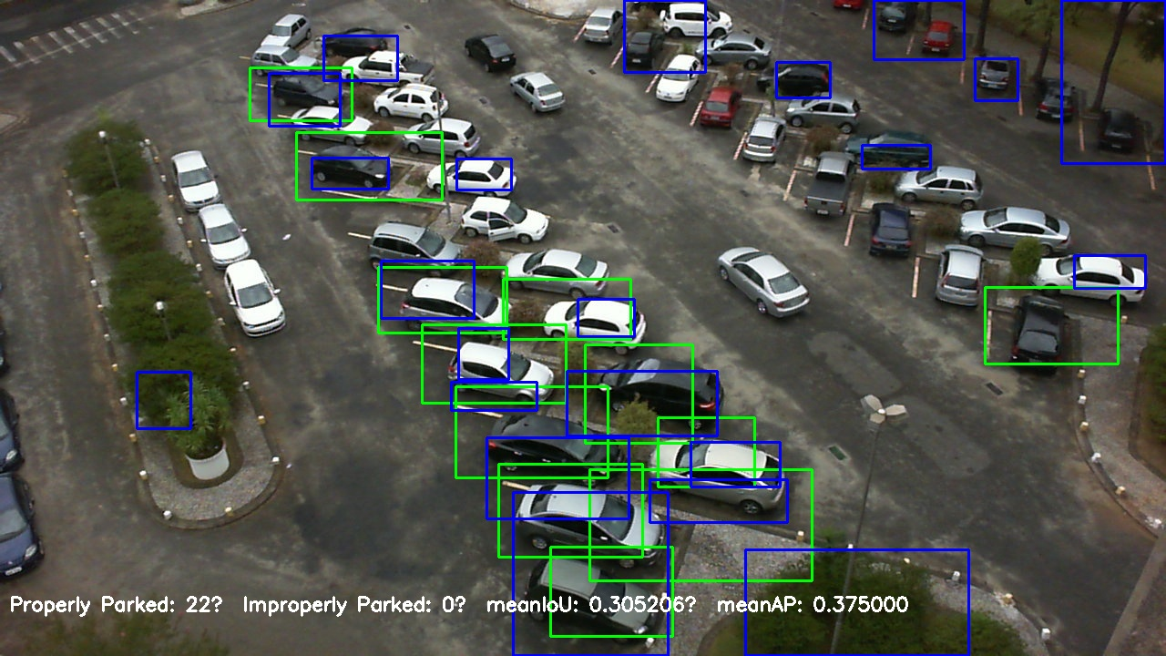

**Sequence 5 mini maps**

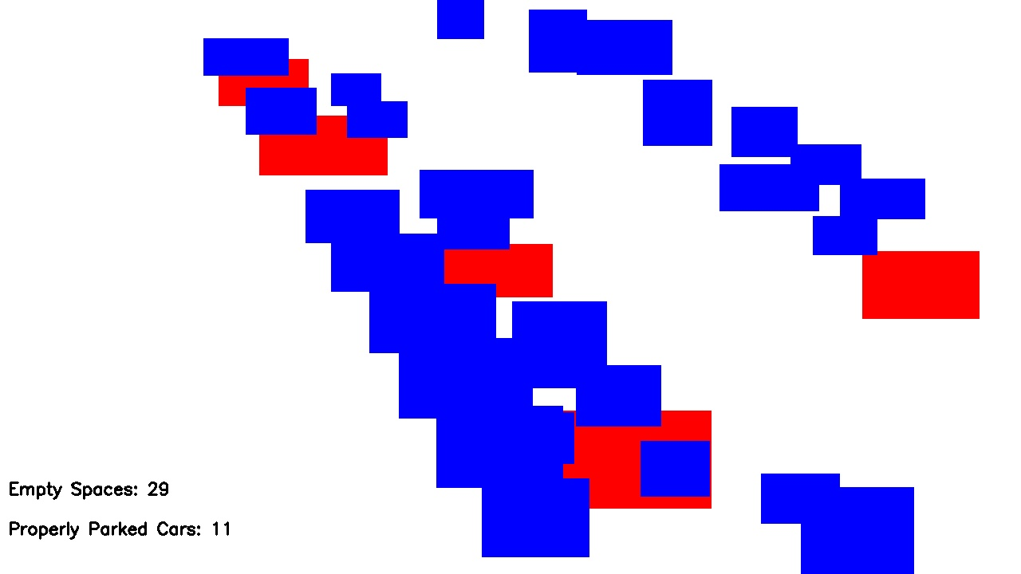

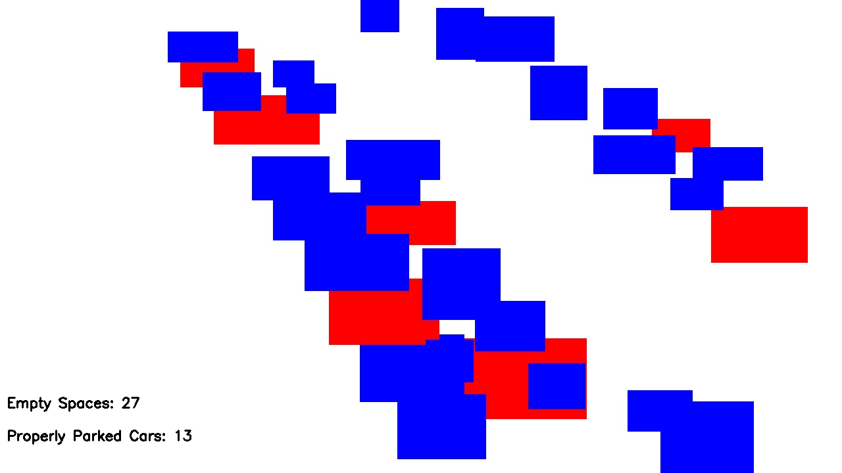

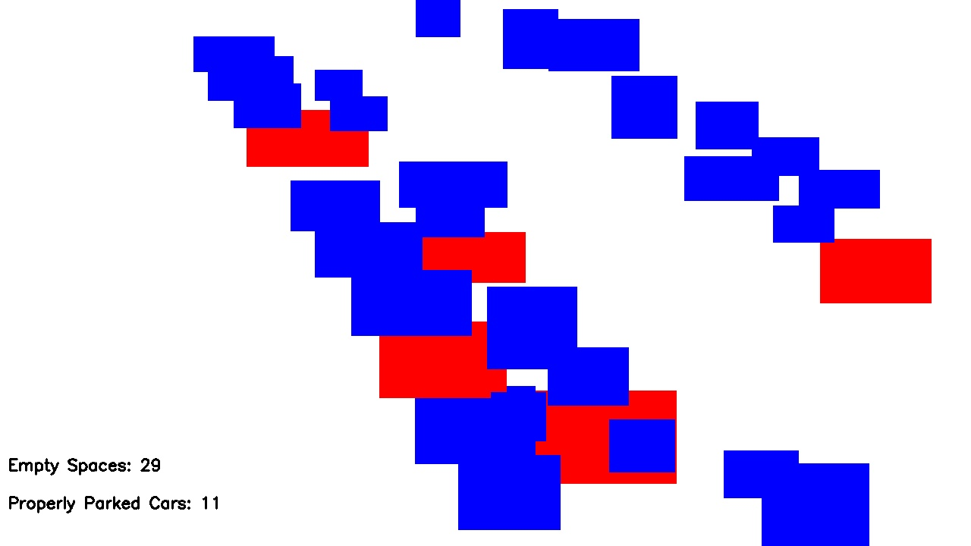

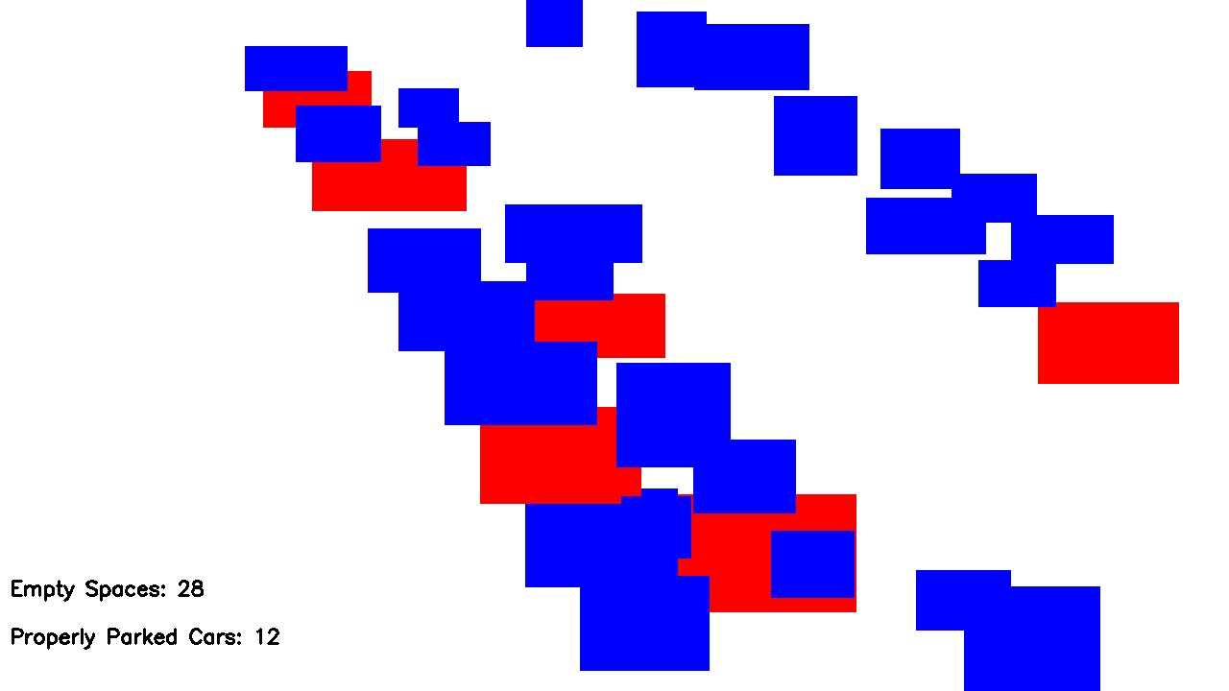

**Ground truth**

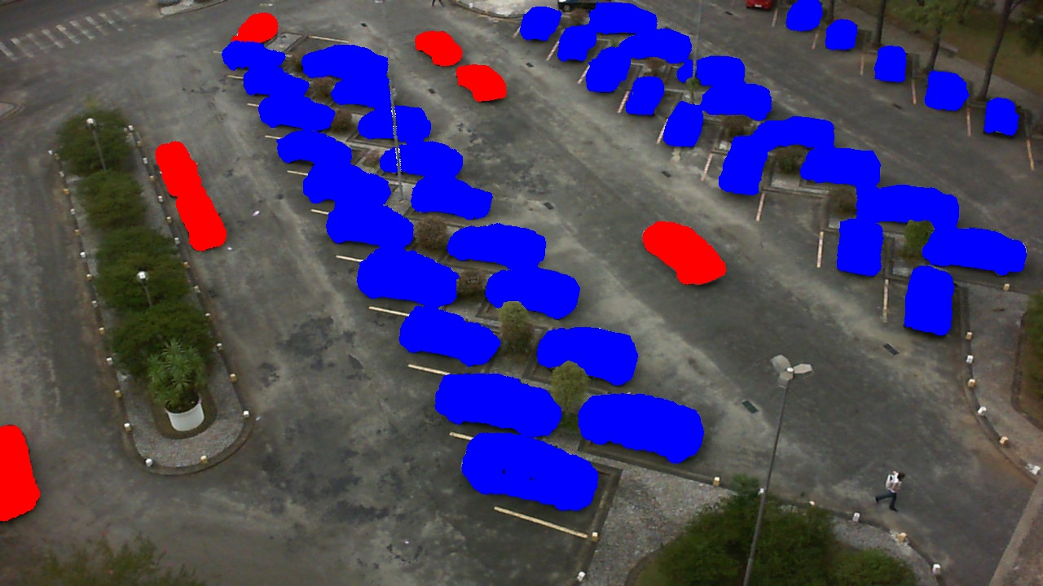

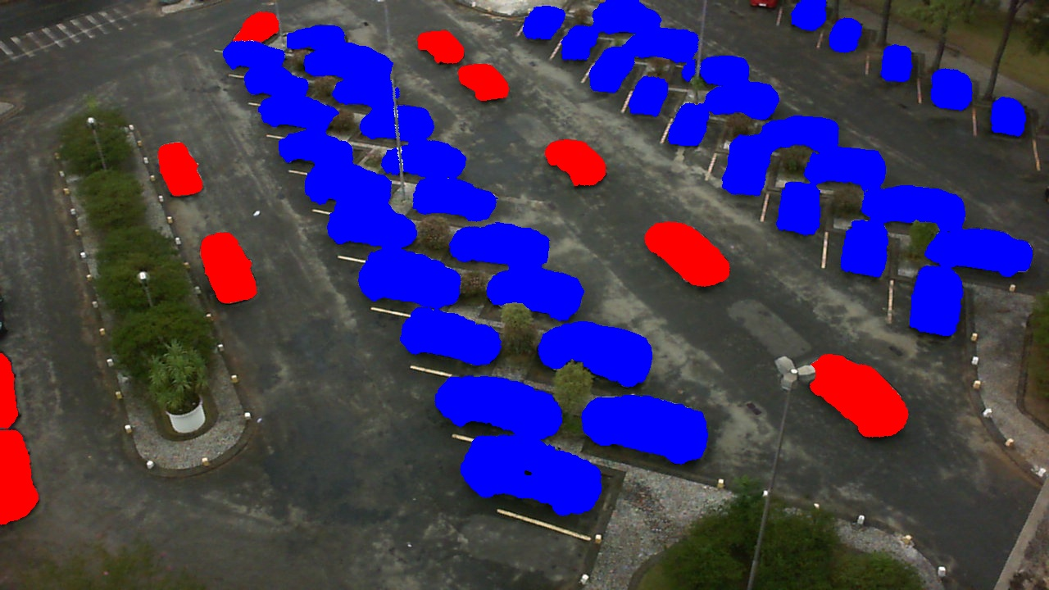

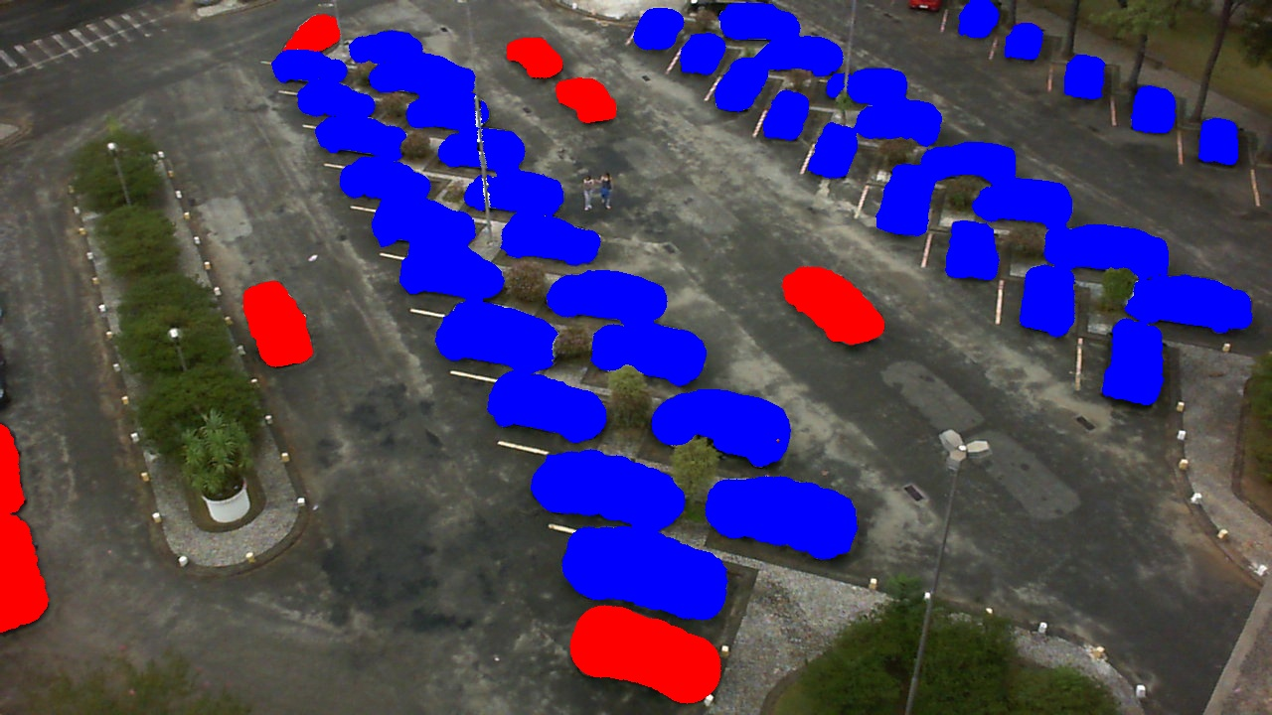

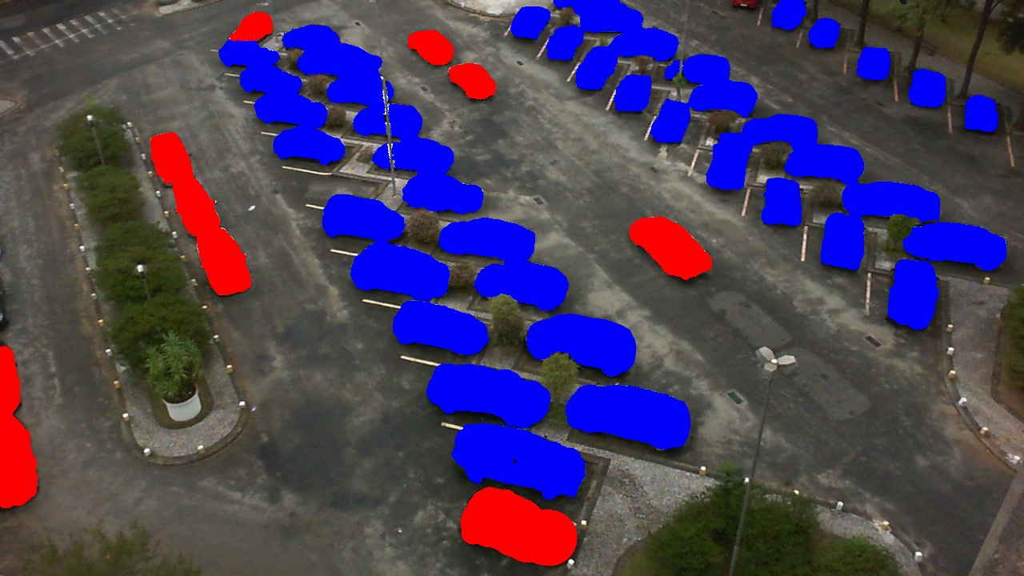

**Conclusion**

In this project, we developed a parking lot detection system utilizing the Hough Line Transform to identify parking spaces and HSV thresholding, edge detection, and morphological operations to detect cars within those spaces. This approach achieved notable success in detecting and localizing parking spaces, as well as identifying some cars, by leveraging traditional image processing techniques and metrics such as Mean Intersection over Union (Mean IoU) and Mean Average Precision (Mean AP). The project required an approximate total of 200-250 hours.

Despite these achievements, This method has limitations, particularly in its ability to consistently detect all vehicles, especially in complex scenarios. The current system's performance could be significantly enhanced by integrating deep learning techniques, which offer advanced capabilities for feature extraction and pattern recognition. Implementing a deep learning-based approach would likely improve accuracy and robustness, leading to a more effective and reliable parking lot detection system. Future work will focus on exploring these advanced methods to address the current system’s shortcomings and enhance overall performance.